Uploading data to the ftp site

Downloading File Zilla Client
Follow the following link
http://filezilla-project.org/download.php and click on FileZilla_3.2.3.1_win32-setup.exe (recommended) to download the client for Windows.

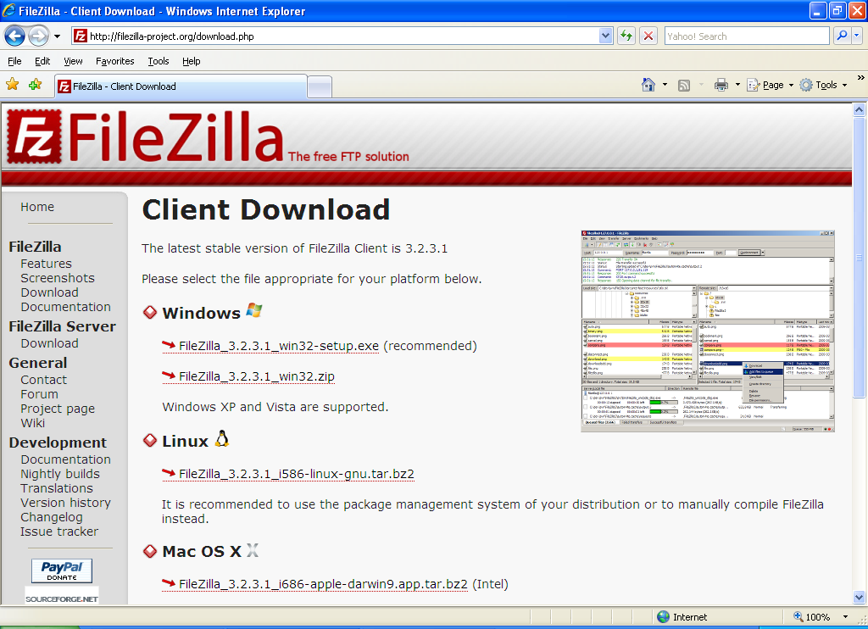

Setting up FileZilla
- Install filezilla.
- On the file menu click on the Site Manager to get the dialog box below and specify as follows:
  - Select ‘New Site’ and name it: ICRAF
  - Host: type ftp.worldagroforestry.org
  - Servertype: Select FTP-File Transfer Protocol
  - Logontype: Select Normal
  - User: icrafftpanon
  - Password: dubai597
- Click OK.

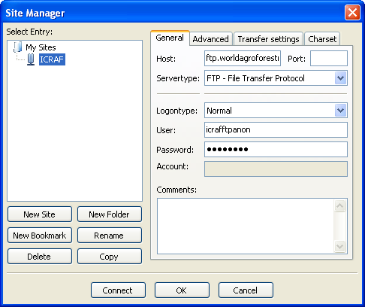

Uploading data
- On the menu bar click on ‘Open Site Manager’ and select ‘connect’
- The left frames of the window show the ‘Local Directory Tree’ which shows data on your local machine and the right frames show the ‘Remote Directory Tree’ which shows data on the ftp site.
- On the local site, navigate through your drives to the folder or file you would like to upload.
- On the remote site:
  - Select DataManagement
  - Navigate to WKIEMP folder
- On your local site click on the folder or the individual file that has data you wish to upload and drag to the remote site.
- It might take a while depending on the number and size of the items being uploaded.

Note: The files being uploaded will be listed at the bottom frame of the window as ‘Queued files” and as uploading continues the failed files will be listed in the ‘Failed transfers’ while the successful files will be listed in the ‘Successful transfers’.

