Data Cataloguing

Data cataloguing generally involves ‘metadata’. ‘Metadata’ is data that describes data. It is a data management tool that uses metadata to describe the data that has been collected during research. During research the researcher collects data regarding the project; these are the project’s metadata which includes: proposals, databases, reports, protocols, spreadsheets, photos e.t.c. The data collected and stored by the researcher also contains its own ‘metadata’ which includes: author of the data, location the data was collected, activity involved, report generated (if any), year e.t.c. Data cataloguing uses database technology to describe the files collected and stored in the database using the files’ metadata.
In a typical organization there is lots of data that is used and every individual has his/her own comfortable way of storing the data. But for the purpose of easier description of the data the paths to the files are ‘harvested’ and stored in a database.

Before the cataloguing begins the structure of the database has to be designed first. This involves first copying the data management database template to your machine then creating the tables and the fields that will hold the data.
To create a table and the required fields, open the database template:
- Make sure the object table is selected on the Objects pane then select the New tab.
- Select Design View from the New Table Menu. Click OK.
- Click your cursor in the first row of the Field Name column. Type the field name for the first field as the name of your table, then press Tab or Enter to move to the Data Type column and select AutoNumber from the drop-down list.
- Repeat steps 3 and 4 to create the fields ‘name’ and ‘title’ and add more fields you would like.
- Select the first field and set it as the Primary Key.
- On the Table Design toolbar select indexes, type ‘identification’ on the Index Name column, select ‘name’ on the Field Name column then set Unique to ‘yes’. Click OK.
- Click on save and give the table the name similar to the primary key then close.

After creating the tables the relationships between the tables have to be created depending on how the tables are related. The relationships can either be one-to-many relationship or many-to-many relationship. Once this is done the structure of the database will be as shown in fig. 1

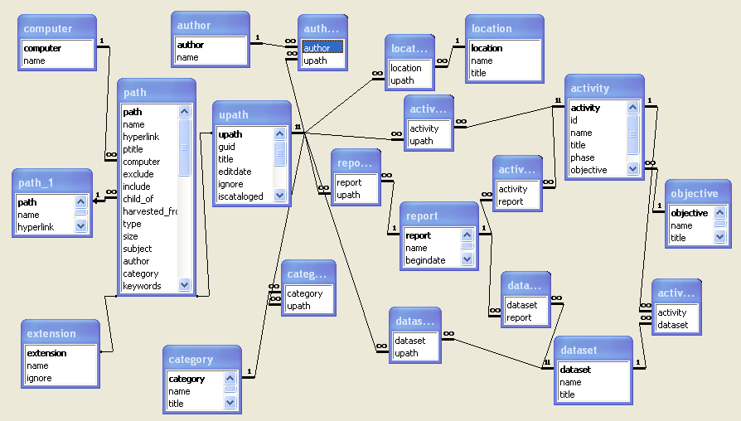

The structure can be represented in a much simpler way which would be easier for the user to understand as shown in fig. 2

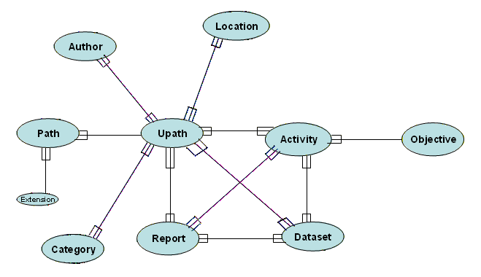

For the data cataloguing system the “wkiemp” database stores the data harvested from the different sources in which they are stored. The Logbook Assistant, part of the Logbook Data Management Toolkit, is used to load the paths linked to the data into a table called ‘path’ in the database. The major reason for harvesting the paths to the files is to allow access to the data itself through hyperlinks.
Once the data is accessible through the database it is subjected to a lot of querying so as to clean and filter out the ‘unwanted’ data. The process of filtering involves subjecting the files to scrutiny and to either accept or reject them. Each filtering process involves creating a query to retrieve the required data and creating an interface to load the data back to the database
e.g. to filter out non-data extensions
- In your database create a new query in design view
- Add the tables ‘path’, ‘extension’ and ‘computer’
- Drag the ‘name’ field in the table ‘computer’ to the first column of the Field List view. Do the same for the ‘name’ field in the table ‘path’ and ‘ignore’ field in the table ‘extension’ as shown in fig. 3

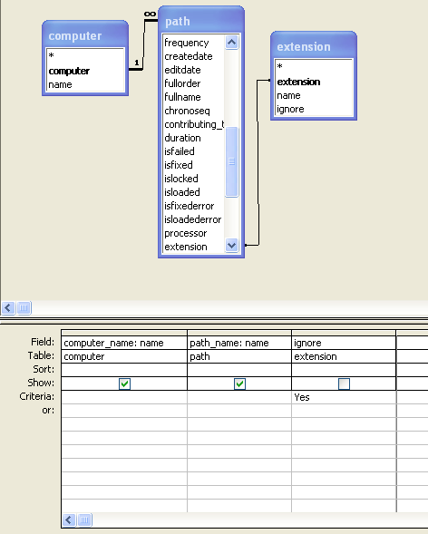

- Save the query and close.
- To create an interface to load the data, open a blank spreadsheet and design it as shown in fig. 4

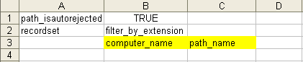

The ‘Data Cataloguer’ is an access database form called ‘upath’ that is driven by the table ‘upath’. The ‘upath form’ contains other sub forms which are forms on their own driven by their respective tables.
To design the ‘upath’ form in Microsoft Access:
- create a query in design view using the ‘upath’ table
- drag the fields ‘guid’, ‘title’, ‘ignore’ and ‘iscatalogued’ to the Field List pane as shown in fig. 5

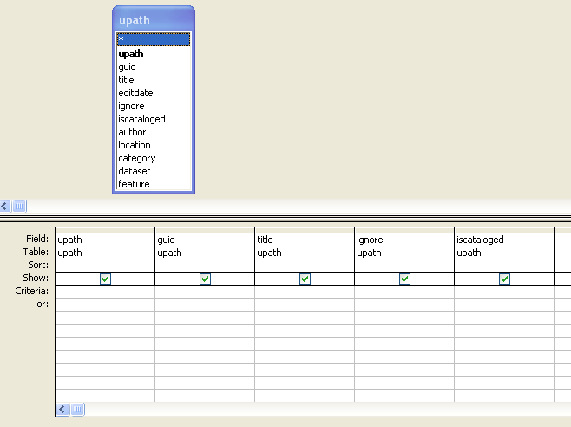

- Save as ‘upathdrv’ and close.
- Select forms in the Objects Pane, click on New and select Design view in the New form window.
- Select the query ‘upathdrv’ and click OK.

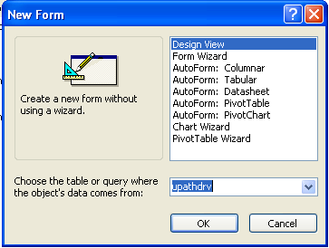

- In the form’s design view drag the fields ‘guid’, ‘title’, ‘ignore’ and ‘iscatalogued’ from ‘upathdrv’ to the form and design it to your likeness.

