Annual Activity Report for Year 2
and Inception Report for Year 3

Western Kenya Integrated Ecosystem Management Project

Louis Verchot

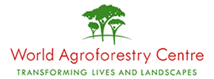

International Centre for Research in Agroforestry
P.O. Box 30677
Nairobi, Kenya

Table of Contents

1. Introduction 1
2. Training 2
3. Species screening trials 2
3.1 Nyando basin 2
3.2 Yala basin 3
3.3 Woodlots 4
4. Baselines 4
4.1 Nyando River Basin 5
4.1.1 Biophysical baseline survey 5
4.2 Yala River Basin 6
4.2.1 Biophysical baseline survey 6
4.2.2 Socioeconomic baseline survey 6
4.3 Nzoia river basin: 8
4.3.1 Biophysical baseline survey 8
4.3.2 Socio economic baseline survey 8
5 Demonstration plots on degraded sites 9
5.1 Lower Nyando Block 9
5.1.1 Meetings 9
5.1.2 Tree planting 10
6. Other support activities 11
7. Activity planning for Year 3 12
7.1 Baselines 12
7.2 Demonstration trials 12
7.3 Training 12

Introduction

Western Kenya Integrated Ecosystem Management Project (WKIEMP) has been initiated with support from the World Bank for implementation through a grant from the Global Environment Facility (GEF). The project, which became effective in July 2005, seeks to improve the productivity and sustainability of land use systems in selected watersheds in the Nzoia, Yala and Nyando river basins through adoption of an integrated ecosystem management approach. In order to achieve this the project will: (i) support on-and off-farm conservation strategies; and (ii) improve the capacity of local communities and institutions to identify, formulate and implement integrated ecosystem management activities (including both on-and off-farm land use planning) capturing local global environmental benefits. The project is based in Kisumu and is achieving its objectives through a community driven development process whereby communities decide on resources for infrastructure investments, technical assistance and implementation of ecosystem management activities.

KARI and ICRAF collaborated in the generation of baseline information that was used in the Project Appraisal Document (PAD) under a Project Development Facility (PDF). KARI requested ICRAF to further continue backstopping the project activities in the 2006/2007 and 2007/2008 work plans with the specific objectives of building capacity of KARI scientists and other local institutions to manage carbon assets including the establishment of a system to monitor and evaluate the biophysical impact of project activities, particularly the impact on net carbon absorption. The main objectives of this backstopping are to assist KARI to:

      - Establish interventions that mitigate land degradation
      - Evaluate and document the potential of different tree species to sequester carbon on degraded land
      - Evaluate options for river bank protection
      - Establish interventions that sequester carbon on agricultural systems
      - Establish PAP intervention plots at several sites
      - Establish a system for monitoring and evaluating changes in carbon stocks.
      - Build capacity of KARI staff, other local institutions and communities to undertake monitoring and evaluation of changes in carbon stocks.

This report summarizes the progress made by ICRAF during the year 2006/2007 with respect to the deliverables outlined in the contract. The report

2. Training

While the major training subjects that have been outlined in the contract focus on carbon measurement and measurement of the non-CO₂ greenhouse gases (GHGs), a number of other ad hoc requests have come from the PCO and additional training sessions have been organized. For example, ICRAF organized a training course on nursery establishment and management. Training was provided by James Owek and Walter Adongo to several KARI staff to support the establishment of the 10 nurseries in the Lower Yala block.

Several trainings were organized that contribute to ICRAF’s contractual deliverables vis-à-vis carbon measurement for the Project including:
- Socioeconomic baseline: Introduction course to the socio economic database. (November 2006)
- Biophysical baseline: Training in vegetation classification and use of the biophysical datasheet. (February 2007)
- Field measurement techniques: GPS and GIS training (1 week course at ICRAF) end June: All FO’s, livestock officer, and M&E team
- Micro catchment mapping in Lower Yala – Sindundu

Finally, in the area of measurement of non-CO₂ GHG emissions from soils, one scientist from KARI Kakamega has been working with the ICRAF team in an area adjacent to the Kakamega forest to learn the field procedures of measuring N₂O and CH₄ emissions from soils.

3. Species screening trials

Nyando basin

We identified 80 potential sites that were suitable for screening trials, but only 47 farmers ultimately engaged in the activity. A series of meetings was held to sensitize these farmers in establishment and management of the trials between October and December. A first baraza was held in December to discuss establishment and management of screening trials Twenty-two farmers participated in the meeting along with staff from KARI, MoA and the environment Officers. ICRAF completed characterization of the 80 trials using the same methodology as was used in the biophysical baseline. Infiltration studies were conducted on 50 of the 80 trials. Planting of the 80 screening trials was completed and a list of the species planted can be found in Appendix 1. One follow up meeting was held. A full list of species screening trials is presented in Appendix 1.
Table 1. Trees planted in species screening trials in Nyando River Basin.

Tree species | Grand Total
Grevillea robusta | 3264
Makhamia lutea | 1008
Acacia passifolia | 218
Acacia gerradi | 310
Acacia polyacantha | 936
Terminalia brownie | 792
Total | 6513

When establishing the screening trials – several farmers were very interested but did not have the required area of 30m x 30m. Here ICRAF established woodlots instead. A total of 29 woodlots have been established and the details are given in Appendix 2.

Yala basin
We identified 160 potential sites that were suitable for screening trials, and all farmers ultimately engaged in the activity. A series of meetings was held to sensitize these farmers in establishment and management of the trials between October and December. ICRAF completed characterization of the 160 trials using the same methodology as was used in the biophysical baseline. Infiltration studies were conducted on 50 of the 160 trials. Planting of the 160 screening trials was completed and a list of the species planted can be found in Table 2. One follow up meeting was held. A full list of species screening trials is provided in Appendix 2.

Table 2. Trees planted in species screening trials in Yala River Basin.
Tree species | Grand Total
Grevillea robusta | 10282
Makhamia lutea | 4141
Senna siamea | 3134
Albizia coriara | 2657
Croton megalocarpus | 297
Casuarina equisetifolia | 601
Croton macrostachyus | 290
Terminalia brownie | 213
Total | 21615

3.3 Woodlots
When establishing the screening trials – several farmers were very interested but did not have the required area of 30m x 30m. Here ICRAF established woodlots instead (Table 3). This met the needs of the farmers, but will not serve the needs of the project per se. However, these plantations will serve as useful demonstrations in these communities to raise awareness about the potential for indigenous species.

Table 3. Tree species planted in woodlots
Tree species |  | No. planted
Various spp. |  | 600
Cordia abssynica |  | 473
Senna siamea |  | 400
Croton macrostachyus |  | 300
Albizia coriara |  | 320
Maesopis eminii |  | 220
Markhamia lutea |  | 270
Grevillea robusta |  | 250
Terminalia brownie |  | 20
Croton Megalocarpus |  | 20
Casuarina equisetifolia |  | 450
Total Seedlings |  | 3323

- Baselines
All block locations were finalized during the year (see Map 1). Baseline data collections activities focused on the Yala River Basin after the sampling was completed in the lower Nyando block. Because of the delays caused by the contract arrangements, ICRAF accelerated the baseline data collections to provide the Project with baseline data in a timely manner. Each block was entered into a separate database and shared with the PCO. Maps for all blocks were prepared and shared with KARI.

The socioeconomic database was modified to accommodate the additional questions and was updated to run more smoothly – ICRAF handed over the modified database to KARI in the fall of 2006 and KARI started entering data by the end of 2006. The biophysical database was also updated.

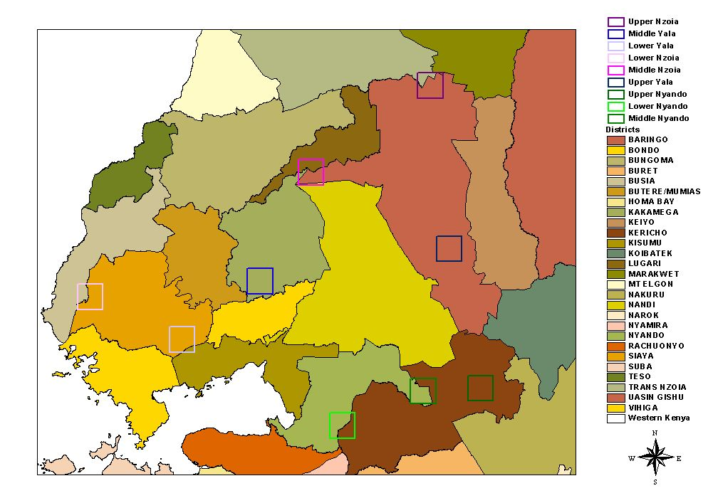
Map 1. Location of WKIEMP 100 km2 focal areas in western Kenya.

Nyando River Basin
    - Biophysical baseline survey
Following the signing of the first contract with KARI, ICRAF mobilized a team to collect the biophysical baseline data from Lower Nyando. Sampling was completed in September 2006. Data were collected from 160 plots and. 320 soil samples were collected for analysis. Infiltration studies were carried out on 48 plots.

Socio economic survey
The team re-sampled all the households in Lower Nyando to ask the added questions to the questionnaire. The task started in mid October and was completed in mid November – all 160 households were identified, however, 4 households no longer existed so 4 new households were included in the survey.

  - Yala River Basin

Biophysical baseline survey
The team commenced the collection of biophysical baseline data in Lower Yala in early September and completed the data collection in early November. The middle block of Yala was sampled from early March and was completed by the end of May: Data were collected from 160 plots and. 320 soil samples were collected for analysis. Infiltration studies were carried out on 48 plots.

Socioeconomic baseline survey

Lower Yala
The team commenced the collection of socioeconomic baseline data in Lower Yala on November 16th and completed the data collection on January 5th. The following sub locations were sampled:

Sub location | Cluster | No. Households interviewed
Kanyardet | 1 | 10
Ndori | 2 | 10
Kambare+Onyinyore | 3 | 10
West Katieno | 4 | 10
Kanyadet+Ndori | 5 | 10
Rera | 6 | 10
Kambare | 7 | 10
Kambare | 8 | 10
Dienya East | 9 | 10
Onyinyore | 10 | 10
Onyinyore | 11 | 10
Ramula | 12 | 10
Nguge | 13 | 10
Uriri | 14 | 10
Gombe | 15 | 10
Uranga | 16 | 10

Middle Yala
The team commenced the collection of socio economic baseline data in Middle Yala on April 10th and completed the data collection in early May. The following sub locations were sampled:

Sub location | Cluster | No. Households interviewed
Mudete & Gaigedi | 1 | 10
Budywa & Vugina | 2 | 10
Savane | 3 | 10
Savane & Museno | 4 | 10
Vokoli & Lusengeli | 5 | 10
Itegero & Bugina | 6 | 10
Chavogere | 7 | 10
Shirulu | 8 | 10
Lusengeli & Jivovoli | 9 | 10
Itegero, Chavogere & Kedoli | 10 | 10
Kaptech | 11 | 10
Kaptech & Lukoye | 12 | 10
Kisasi | 13 | 10
Mulundu | 14 | 10
Muhudu | 15 | 10
Lukose | 16 | 10

Upper Yala
The team commenced the collection of socioeconomic baseline data in Upper Yala on May 21st and was completing the sampling as the year drew to a close. The following sub locations have been sampled so far, the remaining 5 clusters will be completed shortly:

Sub location | Cluster | No. Households interviewed
Yet to be sampled | 1 | 10
Kesses | 2 | 10
Yet to be sampled | 3 | 10
Kesses & Megun | 4 | 10
Tulwet | 5 | 10
Tulwet & Kesses | 6 | 10
Kesses | 7 | 10
Kesses | 8 | 10
Tulwet | 9 | 10
Tulwet | 10 | 10
Kesses | 11 | 10
Kesses | 12 | 10
Koisagat | 13 | 10
Yet to be sampled | 14 | 10
Yet to be sampled | 15 | 10
Yet to be sampled | 16 | 10

Nzoia river basin:

Biophysical baseline survey
The team commenced the collection of biophysical baseline data in Lower Nzoia in early December and completed the data collection in February (the sampling was delayed because of flooding) - 160 points were surveyed and 320 soil samples were collected for analysis. Infiltration studies were carried out on 48 plots.

Socio economic baseline survey
The team commenced work in Lower Nzoia in late December and completed the task during the first week of March. The work was stopped for some weeks in January due to flooding of the block. The following sub locations were sampled:

Sub location | Cluster | No. Households interviewed
Sumba | 1 | 10
Sifuyo & Nambare | 2 | 10
Ruambwa | 3 | 10
Namuduro | 4 | 10
Nyadorera A | 5 | 10
Sifuyo | 6 | 10
Namduru & Sifuyo West | 7 | 10
Kasadodo | 8 | 10
Sigoma Uranga | 9 | 10
Kabura Uhuyi | 10 | 10
Sifuyo West | 11 | 10
Masat East | 12 | 10
Kaugagi Udenda | 13 | 10
Kalkada Uradi | 14 | 10
Masat West | 15 | 10
Masat East | 16 | 10

Demonstration plots on degraded sites

Lower Nyando Block
Rehabilitation of degraded areas continued in Lower Nyando in the 2nd project year. Several more sites were identified and activities were only launched in two new locations: Kowala and Kokoto in addition to the old site of Kalacha. The following activities have been taking place in the 2nd project year in these 3 sites:

Meetings
(Oct.-Dec. 06)
Site | Date | Agenda | No. participants
Kowala & Kalacha | Oct. 23rd | Introduction to rehabilitation of degraded areas | 17
Kowala, Kokoto, & Kalacha | Oct. 27th | Rehabilitation of degraded area | 13, 9, 20
Kokoto | Oct. 30th | Soil & water conservation - Aloes | All group members
Kowala | Oct. 31st | Tree management & other interventions for rehabilitation of degraded areas | All group members
 | Nov. 7 | KARI/ICRAF WKIEMP activities | 11 & 9
All sites | Every Friday | Food for work – meeting the groups & assessment of progress | The entire 3 groups

Periodic group meetings have been held with all participating groups prior to each rainy season to take stock of progress and to plan the way forward for the areas. Meetings were held in January and June 2007 in Kokoto; and in June in Kowala and Kalacha. In Kowala more emphasis has been given to tree management, while in Kalacha the priority has been to develop an action plan for of activities that the group will initiate in the subsequent two seasons. More informal weekly meetings have been held between with the 3 communities every Friday to both assess the work progress and to discuss challenges within the groups.

    - Tree planting:

Table 1 lists the number of tree seedlings distributed to the 3 degraded areas as well as the sister group to Kowala I – Kowala II in the long rainy season of 2007.

Table 1 Tree seedlings distributed in the long rains of 2007

In June, it became apparent that more tree seedlings had been raised than were being planted by ICRAF and KARI. Therefore, ICRAF distributed additional seedlings to the sister group of Kowala I, called Kowala II. The table below lists the species distributed.

Table 3 Tree seedlings distributed in the long rains of 2007 – additional tree distribution

Other support activities
Central nurseries – Kisumu and Maseno:
In the second project year the two central nurseries raised more than 100,000 tree seedlings of assorted species: approx. 60,000 seedlings in Maseno and 46,000 seedlings in Kisumu.

Meetings:
- Stakeholder meeting organized by Friends of Katuk (FOKO) – November 21st 2006 – join attendance of ICRAF and KARI
- Meeting at KEFRI Maseno on tree growing – join attendance of ICRAF and KARI
- Sensitization meeting in Lower Nzoia river basin – Usonga Location, Uranga Division, February 28th 2007
- District Environmental Action Plan Meeting held at Nyando District Headquarters at Awasi - May 16th 2007
- Sensitization meetings in Upper Yala block – series of meeting between May 11-23rd 2007
- Professional Group Workshop Held at Maseno ATC on May 29th 2007
  - The workshop was convened by the Provincial Director of Agriculture in Nyanza – joint attendance of ICRAF and KARI
Students:
In the second project year, ICRAF has had 2 MSc. students attached to the WKIEMP project. One student (Johannes Rupp) is looking at local institutions and the linkage to the global carbon market, whereas the other student (Peyton Smith) is looking at agroforestry in relation to soil and water conservation using GIS. These students have been supported in the project under additional funds raised by ICRAF to supplement GEF funding.

Activity planning for Year 3

7.1 Baselines
The major activities for year three will be finishing the baseline. Due to the delays in signing the contract between KARI and ICRAF, data collection, which was originally scheduled to cover 30 months need to be compressed. At the same time, with decisions that have been made within the project to scale back the number of blocks, sampling will take less total time than originally planned. We anticipate completing all field collection – both socioeconomic and biophysical by the middle of the year. Data analysis and baseline reports will be available early in the fourth quarter of the year. However, to facilitate more efficient project planning and implementation, all databases will be shared as soon as possible.

Demonstration trials
ICRAF will expand the species screening trials and land rehabilitation trials in year three, particularly in lower Yala (Alwala and Sidundu). Expansion will primarily be done during the long rains. Two sites in lower Yala have already been identified for rehabilitation. Monitoring will continue on the species screening trials in Lower Nyando and Lower Yala blocks.

Training
KARI has identified the need for training in GIS and remote sensing basics to assist with project planning and activity monitoring. Gaining these skills is an essential prerequisite for more advanced work in carbon measurement and monitoring. Thus, ICRAF has proposed three modules:
- An introduction to GIS;
- Spatial analysis
- Integration of GIS and remote sensing
These modules will be offered during the third and fourth quarters of the year.
Appendix 1 – Species screening trials in Lower Nyando – 47 trials
Plot ID | Farmer Name | Sub-location | Species planted | Infiltration (+/-)
019 | Leonard Akach | E.Jimo | M.Lutea+Grevillea | +
027 | Daudi Keter | Tabita | M.Lutea+Grevillea | +
029 | Philip Kirui | Tabita | A.Poly+Grevillea | +
030 | Yukabeth Owino | E.Jimo | M.Lutea+Grevillea | +
031 | Ojuang Ko’mbudo | E.Jimo | T.brownii+ Grevillea | +
033 | Micheal Odhiambo | E.Jimo | T.brownii+ Grevellea | +
034 | John Otieno Owouth | E.Jimo | A.gerradi+Grevillea | +
035 | Henry Ochieng | E.Jimo | M.lutea+ Grevillea | -
036 | John Okendi | E.Jimo | A.Poly+Grevillea | +
037 | Monica Opiyo | E.Jimo | A.Poly+Grevillea | +
038 | Pauline Obuom | E.Jimo | A.Poly+Grevillea | +
039 | Ann Obuom | E.Jimo | A.Poly+Grevillea | +
040 | Steven Ochieng | E.Jimo | A.Poly+Grevillea | +
041 | Japheth Adera | E.Jimo | T.brownii+ Grevillea | +
043 | Jeremiah Okumu | E.Agoro | M.Lutea+Grevillea | -
051 | George Otieno Ogada | E.Jimo | A.gerradi+Grevillea | -
056 | Were Olonde | E.Jimo | A.passi+ Grevillea | +
057 | James OtienoManga | E.Jimo | A.gerradi+Grevillea | +
058 | Shadrack Jole | E.Jimo | T.brownii+ Grevillea | +
059 | Hellen Okoth | E.Jimo | T.brownii+ Grevillea | +
060 | Ann Owour Owiti | E.Jimo | T.brownii+ Grevillea | -
063 | Silpha Were | E.Jimo | A.Poly+Grevillea | -
062 | Samson Otieno | E.Jimo | M.lutea+ Grevillea | +
064 | Fransico Okwanya | E.Jimo | M.lutea+ Grevillea | +
065 | Caren A. Onyango | E.Jimo | M.lutea+ Grevillea | -
066 | Silvanus Pila Gunde | E.Jimo | A.Poly+Grevillea | +
067 | Silvanus Aoko | E.Jimo | T.brownii+ Grevillea | +
069 | Benard Ojijo | E.Jimo | T.brownii+ Grevillea | +
070 | Leonard Nyaoke | E.Jimo | M.lutea+ Grevillea | +
071 | Okoth Mwana | E.Jimo | A.Poly+Grevillea | +
072 | Peter Ochieng | E.Jimo | A.Poly+Grevillea | +
073 | Jared Omondi | E.Agoro | A.Poly+Grevillea | +
074 | Risper Owiti | E.Jimo | T.brownii+ Grevillea | -
075 | Benjamin Oriato | E.Jimo | T.brownii+ Grevillea | -
076 | Janes Okelo Opiyo | E.Jimo | A.passi+ Grevillea | -
077 | George Akach | E.Jimo | A.gerradi+Grevillea | -
078 | Onyoungo Pri. Sch. | E.Jimo | M.Lutea+Grevillea | -
079 | Joseph Molla | E.Jimo | A.Poly+Grevillea | -
080 | Deborah Juma | E.Jimo | M.Lutea+Grevillea | -
0xx | Lilian Otieno |  | T.brownii+ Grevillea | -
068 | Yogo A. Fannel | E.Jimo | A.passi+ Grevillea | -
020 | Morris Mbhya | E.Jimo | A.Poly+Grevillea | -
009 | Clement Odera |  | T.brownii+ Grevillea | -
010 | James Ojwang |  | M.Lutea+Grevillea | -
061 | John Apiyo Bnodo | E.Jimo | M.Lutea+Grevillea | -
0xx | Jacob Ila | E.Kabodho | M.Lutea+Grevillea | -

NB: The full names for the species are as follows: T.brownii – Terminalia brownii; A.Poly – Acacia polyacantha; A.gerradi – Acacia gerradi; A.passi – Acacia passi; Grevillea – Grevillea robusta; M.lutea – Markhamia lutea
Appendix 2 - Tree seedlings planted in woodlots & boundary planting by Kowala Environmental Rehabilitation group members on their farms, Lower Nyando
Appendix 3 - Tree seedlings planted in screening trials in Lower Yala– 160 trials

