WESTERN KENYA INTEGRATED ECOSYSTEM MANAGEMENT PROJECT (WKIEMP)

STRATEGIC ALIGNMENT WORKSHOP

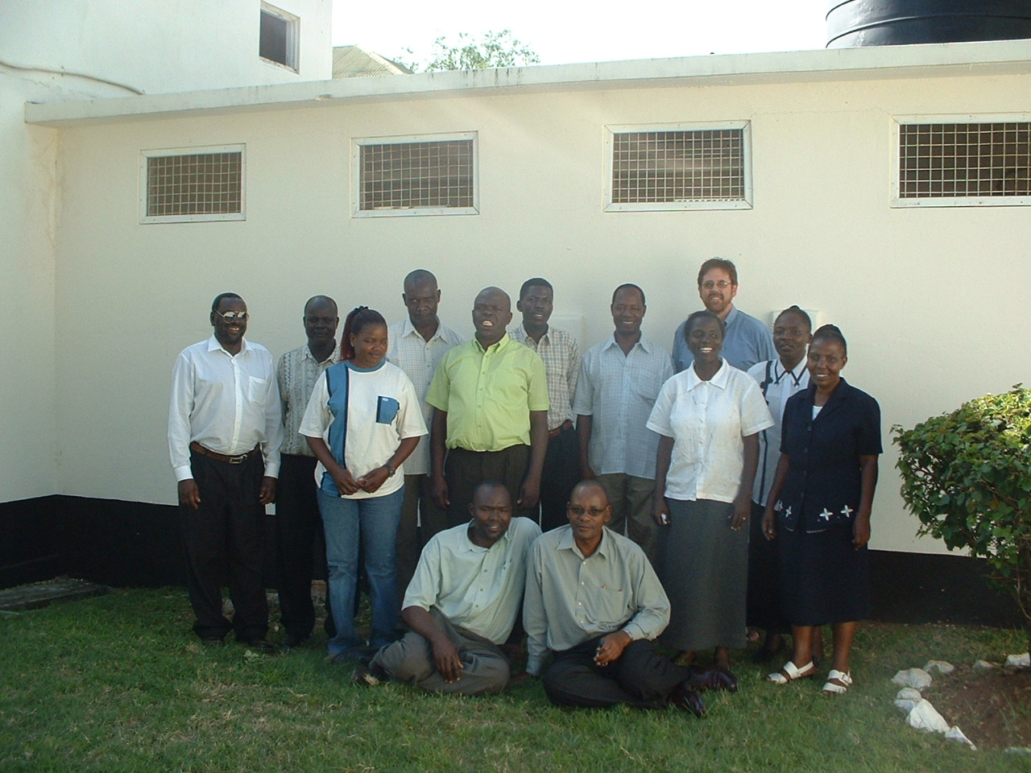

KISUMU
25/26th January 2007

Background.

This World Bank funded collaborative project between KARI, ICRAF and farmers in Western Kenya is now in its second year. A two-day workshop was held in Kisumu for The KARI and ICRAF team members to take stock of the modus operandi of the whole team, to start to develop an implementation plan and a set of working agreements on the most effective way forward.

Thursday 25th January 2007

After registering and doing a small exercise to introduce each other, the team shared their thoughts on the purpose of the workshop and the working agreements between themselves for conducting the workshop.

Purpose of the workshop

- Find out how we can all work together towards a common goal
- To become more cohesive
- Develop commitments and understand different and shared aspects of responsibility to get things done
- Collectively identify clear vision, work out modalities of reaching that vision
- To reflect on past working relationships and to chart the way forward
- To learn how to respect other peoples’ opinions
- Exchange views and field experiences
- Build a team

Workshop agreements

- Come back from breaks on time
- Mobile phones off
- To respect each others opinions
- Everyone participates
- Whatever is discussed here will not be taken outside
- Positional caps left at the door
- No smoking

THE VISION OF THE PROJECT

Research on Scientific Research Teams has demonstrated that a commonly shared clear purpose is the most important key factor that contributes to the success of the team. The team then looked at what constitutes the whole of a clear purpose, and in three small groups, generated their visions for the project

THE KEY OBJECTIVES OF THE PROJECT

The group then split into three smaller groups and created cards on what they thought are the key objectives of the project that will allow the vision to be realised. There was consensus across the three as the objective fell into seven categories that were then later diminished into three ( biodiversity probably needing to be reincorporated). Once all the cards with all the objectives from all three groups had been put on the wall, each person was given first three green stickers, then three red stickers. the green stickers represent what will give each team member personal satisfaction if it is achieved. The red stickers represent the team member's understanding of the World Bank’s key priorities. All the objectives, including the duplicate cards from the different working groups are captured below.

- Empower communities to sustainably use their natural resources and hence improve their livelihoods (8 red 8 green)
- Empower communities to better manage natural resources (I green)
- Increase livelihood options

- Increase land productivity (11 green 7 red)
- Increase land productivity through better agricultural practices (I green)

- Increase useful biodiversity in agricultural landscapes (3 red 3 green)
- Restore and manage biodiversity

- Mobilize communities for collective action planning and implementation of IEM (2 green)
- Catalyze various stakeholders participation synergies in IEM
- Strengthen research extension and farmer linkages
- Sensitise and inform policy makers on IEM (I red)
- Build the capacity of stakeholders on integrated ecosystem management (2 green)

- Reduce erosion and nutrient depletion and improve quality of soil and vegetation on degraded lands (5 green 4 red)
- Reduce land degradation by x% (3 green 4 red)
- Reduce further land degradation (1 green)
- Protect water catchments for better regulated flow and water quality (3 green)

- Reduce rural poverty by y % ( 6 red 1 green)

- Sequester Carbon through sustainable land management practices (3 green 11 red)
- Promote agroforestry practices to enhance carbon sequestration (1 green)
- To carry out target research on greenhouse gases (1 red)
- Empower communities/institutions to participate in carbon trade

The group then reviewed where the red and green stickers seriously diverged and had a full plenary discussion. It was noticed that there was a lot of agreement about empowering communities, increasing land productivity and livelihoods and decreasing land degradation.

However, it was recognised that there was large gap in understanding and being able to implement the carbon sequestration aspect of this project. At this point in the workshop only 6 out of 15 present thought that this project was focused on planting large numbers of trees. Almost no one on the project team was aware of or had seen the original project document that was submitted to GEF. One team member described the origin and history of the project in full and it was agreed that all team members should have ready access to the original document, not just to the World Bank project appraisal document.

In general, the issues arising out of this exercise that were discussed covered.

1) How to reach internalisation of carbon sequestration and trading by the team members – 500K$ of the original project money went for capacity building on Carbon to Nema
2) What actual sequestration targets will the team decide to achieve? There is a large difference between the WB Project appraisal document (3.3 tons per hectare, which can be achieved with grass) and the original project document submitted to GEF which targets 180,000 tons of Carbon sequestered by 2010, which can be achieved by 2.5 million trees on 2,500 hectares across one or more of the blocks).
3) How can the team really motivate farmers towards planting and tending trees?
4) Is the team simultaneously testing the hypothesis adopted within the project that increasing farmers incomes through poultry and other on-farm activities does lead to a decrease in the number of trees cut down for charcoal or increases the farmer's motivation for planting the 2,500 hectares of trees in the ecosystems close to the lake as suggested in the first project document to GEF. Can this hypothesis be tested out within the M&E framework currently envisaged?
5) Some of the initial modalities of the project, such as main field officers living in the field have been modified. Does this also modify the ability to work well with the communities and to leverage partnerships with other CBOs’ and organizations involved in tree planting?
6) Is there anyway to speed up the flow of funds through the ministry/Kari pipeline so that on the ground activities are not delayed?

Other thoughts that backed up this discussion were to do an initial grouping of the activities listed on the proposed strategic implementation framework that would lead to the objectives. These are listed below.

- Improved livelihood activities: micro-irrigation, livestock, honey, agroforestry, sericulture
- Improved land production – agronomy, agroforestry, forage, water harvesting.
- Rehabilitation of degraded land- enclosure, soil and water conservation, farm forestry, agroforestry

The team examined the budget spread in order to see whether or not that might define any priority objectives or activities.

The budget: Scaling up and financing IEM interventions 1.5m $
Project coordination 950K$
Monitoring and Evaluation 900K$
Capacity building 700K$ of which 2/3rds is for carbon finance.

The team also explored what they feel is the difference between an IEM intervention and one that works with many individual farmers of farmers groups to improve their livelihoods and their use of their resources.

What is an IEM intervention?

Something beyond farm scale into ecosystem level not at individual farm level
Look at collection of interventions at the ‘collated ‘ level
Having a basket full of different interventions which encompasses programme technologies

The team reiterated amongst themselves that there is an urgent need to :-

- Agree carbon sequestration targets that work for the project.
- Properly monitor and test the hypothesis of whether increased poultry and livestock income stops farmers cutting down trees for charcoal. Need an in depth study as to why farmers keep larger less sustainable herds.. as bank accounts? Need to work to change attitudes.
- Monitor whether or not poultry, beekeeping, livestock is working as an incentive towards engaging farmers in enter into the other IEM and carbon sequestration IPG aspects of the project and to plant and tender to many trees.

The team then broke for lunch. After ,lunch, they returned and sent ' presents ' to each other as individuals, sharing what they have really appreciated about each other in working together. They then explored the basis of good collaboration, and the different roles individuals and organisations can play in collaboration.

What forms the basis of good collaboration?

- Honesty, Integrity
- Appreciation of different responsibilities
- Open-mindedness, flexibility
- Competence, co–operation
- Effective communication
- Complimentary skills- each person adds something different
- Sharing of major resources
- Shared vision, clarity about what you are collaborating on
- Trust

Collaborative roles on project

Partners- Kari, ICRAF, communities = organized groups
Need all three, each one has a comparative advantage
Kari has larger administrative role, conduit of budget, signatory
If ICRAF is seen as technical support by World Bank and different budget lines have been assigned to each institution, how can the teams remain seamlessly cohesive and as equal partners on the ground?
How do you manage these financial and administration challenges?

Working first in three small groups and then collating their thoughts, the team then shared what they felt has gone really well so far in the project and what can still work better.

WKIEMP Collaboration

What has gone really well so far?

- Joint planning and capacity building for tree nursery establishment
- Community mobilisation
- Collective baseline information is underway
- Bi monthly planning and progress meetings
- Attending COP 12 meeting
- Better sharing of info and data
- M&E of vegetation carbon changes
- Sequence of now entering blocks is now taking shape
- Sharing of resources
- Improved collegiality
- Increased consultations

Much has improved last three months

What can get better?

- Sharing resources
- Clarity of roles and responsibilities of institutions
- Further strengthen communication linkages
- over-expectations of communities, low project ownership
- Community perceptions of individual institutions has not changed
- Low level of institutional and individual trust
- Unequal representation of institutions at bi-monthly meeting
- Modalities for sharing core functions
- Harmonising community activity and approaches
- PAP formulation implementation modalities
- Harmonise understanding of the project
- Disparity in subsistence entitlements during field activities for staff and communities
- Clarity of M&E, common approach

Later on in the second day the team also thought about innovative ways to be seen as and to act as one team in the field and with the communities.

How do we go as one project to the communities

- Honesty and trust
- Do not amplify each others failures, shortcomings
- E.g. KARI does not pay cash to communities. ICRAF has paid cash in kind for giving maize and pays contact farmers to find other farmers. Why not use government extension workers already in the field?
- Also giving sodas and bread at farm meetings.
- Need to develop project guidelines, especially on approaching the communities
- Food for work
- It is already agreed that these issues will be worked out and harmonized when Anja returns.
- Those groups that have been mobilised by one institution should not suffer when the budget is with the other
- Each person in the field needs to be funded by heir own institution. ICARF needs tow days advance warning otherwise needs to pay form own pocket and be reimbursed.
- ICRAF trails need to be fully integrated into the project and be designed and carried out by the communities
- Having a rhythm of bi-monthly meetings, move a planning one to Friday so that ICRAF field staff can participate once a month
- Put up signs saying KIEMP/KARI?ICRAF joint project in the blocks.

In the last session after tea on day one the team filled in a questionnaire about preferred ways of working which led to discussions about deadlines, commitment, leadership and giving and receiving feedback. The emphasis was on how each person is different and even has different perceptions about how it is in the same one team... that no one is right or wrong and how people feel will be based much on their experiences within the team as on their own personal preferences.

It was also emphasized that the second critical success factor in any scientific research team is to want to work together and the good will to make it work. Recognising, appreciating and setting up agreed modes of working that encompass and respect each others different expectations is key to this success. [ see appendix one for questionnaire and results. ]

Friday 26th February

On the second day, the morning was taken up with developing the key targets and activities under each key objective, discussing them through in some depth and agreeing an action plan for developing this implementation plan further. It was appreciated that biodiversity needs to be more included in this plan. The Team decided to photocopy the log frame of the original GEF proposal as it was felt this would help to flesh out some of the more generalised targets and activities described in the World Bank Project Appraisal document that derived from this former document. The team's first thoughts for more specific targets and activities are attached in the attached Excel file. It is clear that a detailed master implementation plan outlining which group of technologies will be applied, in which order, and to what extent in each block needs to be completed as soon as possible. There was however a general underlying consensus within the team that while creating the baselines and presence within all blocks, it will work well for the team to focus its current efforts on getting it right in three or four blocks and extend the learning to the other blocks.

Action plan for implementation

Plan
Tuesday 30th form 3 subgroups collate by Friday 2nd February. Share on Monday 5th Meet on 6th
Empowering communities – Samuel, Christine
Degradation- biodiversity Eva Wilson Keith on e-mail

The action plan for building the WKIEMP team's capacity in carbon sequestration techniques and understanding was laid out as:

Activity | When | Who responsible | Achieved
1 1/2 - 2 hour meeting with question and answers.  -WG documents,  -CD4CDM manuals  -Encofor PDD documents | 6th February 2007 | Lou to run this session
ICRAF Biophys team work with ENCOFOR biophys manuals with Eddah
KARI Socio-econ team work with ENCOFOR socio and economic tools with Lou's support
Discussion of experiences of each team | First bi-monthly meeting in March
ENCOFOR consultants visit | Last week in March
George/Jane being interaction with Emily Massawa at NEMA to support Carbon Marketing | MARCH
As blocks come on line work with PDDs for each
Focus on community sensitization re carbon sequestration. Look at Plan Vivo materials | 2nd half of year

The team then returned to thoughts on team work. the facilitator shared some of her experiences and best practices working with teams.

The Established Team Basics
- Clarify common Vision, Purpose, Goals, Objectives, Tasks.
- Work out roles, responsibilities and accountability.
- Spend sometime highlighting the breadth and depth of experience, skills, styles and personalities within the team, celebrate and legitimize the differences.
- Create working agreements, especially ones that will make the most of the different knowledge, expectations, communication styles (on and off line) and experience within the team. These agreements can also usefully minimize miscommunications, gossip and frustrations, (especially with email), level the playing field and establish acceptable ways of resolving conflicts.
- Establish rhythms and norms of communication that allow for language differences, uses of English (US or UK) as a second language, different communication patterns and very itinerant members.
- Create a sense of community based on mutual respect, openness, reciprocity and mutual confidentiality where necessary.
- Work out copyright issues and who will receive explicit and implicit credit for what.
- Jointly work out the most appropriate leadership style and needs for the context and task and empower the leader to lead.
- Make sure meetings are fun, efficient and effective and that everyone has participated as much as they wanted to.
- Create a steady rhythm of face to face/online at a distance work.
- Give credit where credit is due. Celebrate milestones .
- Work out up front how you are going to wrap up, measure impact and pass on the learning.

The even more basics if you have very little set up time.
- Make sure you are all clear about the purpose of the team and establish mutual respect, reliability and active trust from the start. .
- Keep the core team small (5 people is optimal) and network others as and when needed.
- Establish a few simple ‘do’s and don’ts’.
- Make sure someone is always scanning the environment for change and useful information, connections.
Experience says you also need to:
- Do what you say you are going to do, in the time agreed. Otherwise, keep the other people well informed of your likely delays. Work actively to build reliability, trust and confidence of the others in yourself.
- In difficult situations, anticipate, diffuse, disarm and stick to the facts.
- Build a culture where you are free to question assumptions near the bottom of the ‘Ladder of Inference’. Balance advocacy with inquiry; e.g. Leave space for the other person to question and share their perceptions when you say things.
- Be the one to reach out and actively promote goodwill. If in doubt, assume good intent until you can prove otherwise. Proactively ‘clear the air’ and build in some fun and off-line social interaction.
- Be ready to have heated debates about matters of science without (necessarily) taking it personally.
- Consciously spread positive gossip (more than negative!). Best of all, find some acceptable way to say what is on your mind to the person directly concerned and so create fast internal feedback loops.
- When a misperception or problem is resolved… move on and do not keep going on about it. Keep focused on moving forward.

The team then spent some time thinking about effective communication and when and how to give each other useful feedback in order that it is a fast and relevant as possible within the team to keep it healthy.

Communication

Verbal signals ( 52%) count more than tone ( 39%) which counts more than words.(9%)
E mail is low context. What can assist successful emailing?
Err on politeness
Formality
How much exchange is polite before getting on with work?
‘Flaming’, the speedy escalation of conflict on email. Pick up the phone if things seem harsh
Contextualise
Netiquette- make sure the subject of the email explains what the email is about, keep one topic per email, number questions so someone can respond clearly, maybe come up with team set of symbols to indicate whether the email is urgent and needs someone’s action or just for background information etc.
Be aware of best use of sms/mobiles, landlines, face to face meetings.

- ACTION: - Move at least one bi-monthly planning meeting to a Friday so that more ICRAF staff can attend.

Feedback

When do you give feedback?

- At a time when there is no stress ( things may have cooled down)
- When someone else is ready to receive
- As soon as possible
- Privately rather than publicly, especially if it will be conflictual
- Use third party/mediation
- Assume good intent
- Constructive- but carefully explaining/suggesting how something can be improved
- Be specific
- Be honest stick to the facts
- Do not be judgemental
- Avoid ‘ never’ ‘always’
- Give it when people ask for it.

‘When you do x’
‘I feel / experience y’
‘Can we…..?? ‘

The team then worked in two groups and generated a list of agreed do and don'ts that they feel are important to keep the team energy positive and coherent.

Group one: Effective communication and feedback in the project team.

Sources of conflict

- Mode of entry into the new blocks.
- Context of community meetings
- Different community communication approaches
- Inadequate inter/intrapersonal communication

Solutions

- Shared weekly/monthly work plans.
- Reorganise project activities with communities especially in Nyando.
- Non-prejudicial problem-solving techniques especially at the lowest/relevant levels.
- Sort it out at the level at which it is happening rather than send difficulties upwards.
- Sharing field experiences and expertise amongst the project team
- Synchronise related activities to build synergies
- Respect each/one another's opinions and avoid criticism in public/community
- Avoid ready answers to the communities - always consult before committing other team members
- Be open to one another.

There was in- depth debate about the different ways in which the two organisation approach and work with Farmers. In some areas, ICRAF has been giving out maize and when the maize harvest was on, instead of maize they gave out cash. They also might pay a farmer to ' find' and 'hire' other farmers into the project. KARI does not do that, so when communities hear that, the farmers can express frustration at the lack of incentives from KARI. There was also in-depth discussion on the different institutional policies on per diem/Field/Lunch and sharing lunch with farmers or not. It was agreed as far as project staff members are concerned each staff member has to abide by the protocols of their individual institutions and not expect the other institution to change at that level just for the project as this will create problems within each institution. It was agreed though that whenever communities are involved, then there needs to be a shared set of protocols that both institutions abide by so that they are seen to be acting as One Project, WKIEMP. It was agreed that these need to be worked out in detail and shared. Given these guidelines, it was clear there was goodwill amongst the team to assist each other on the day to day ground level to make things work when necessary.

'Group Two' feedback on WKIEMP team working agreements.

Do Not:- :

- Talk behind each others back
- Implement activities that are not in the project's core objectives
- Make promises on behalf of the project which will be difficult to deliver

DO: -

- Commit to do what is agreed
- Give feedback if you are in doubt as to whether or not you will meet a deadline
- Be honest in what we say or do
- Do exhaust all avenues of resolving conflicts at ground level before contacting higher levels.
- Continuously refer to agreed objectives and workplans
- Be willing to share resources
- Aim to promote appropriate interventions
- Consult before you promise to deliver
- Submit individual work plans and budgets in time
- Submit back - to -office immediately upon return
- Encourage horizontal exchange of information
- Vertical flow of information up and down should follow laid down procedures
- Remember to give credit where credit is due!

After a group photo and exploring naming the team ' The Kijani KibichERs ( Ecosystem Restoration) the team reviewed the workshop and the outcomes and closed.

