If the existing shapefile in ArcView and excel file have a common attribute “NAME” then you can join these files and use excel data for analysis.

This is procedure to join these files.
- Open your excel data and save it as DBF (IV) format.

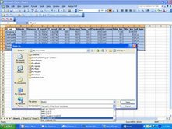

- To do this, highlight the data in excel and go file menu (under excel) and select SAVE AS
- Select the folder where you want to save your work, Scroll Save as type to select DBF 4 (dbase IV)
- Type the name of your file, and click SAVE.

- Open ArcView and display the shapefile with which you want to join with the excel data.

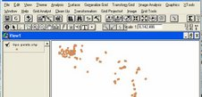

- Close View Item and open Table

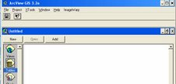

- Click add to bring your excel data saved as DBF.
- Once added you can open this table to view your data.
- Open the table of your ArcView shapefile, by using OPEN button under table and look for your shapefile from the folder.
- With two table open, click the common attribute from each table is a sequence, starting “NAME” from excel data and “NAME” in shapefile.

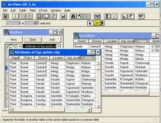

- Click “JOIN” button to merge the two tables. With this join command, one table “from excel” will disappear.

- You can now go View and display your join shapefile using data from excel
- To keep the JOINED table permanent, save your shapefile with a new name, otherwise when you quit ArcView, the join table will disappear.

Try this procedure and let me how far you can achieve it.

Thanks

