a.
b.

Source: (FAO, 2003)

Figure 6: a) Average annual precipitation (mm), and (b) average annual temperature for the study area

a. Average Annual Precipitation (mm)

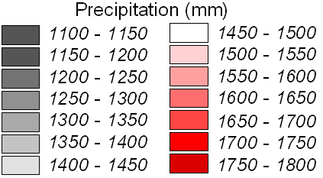
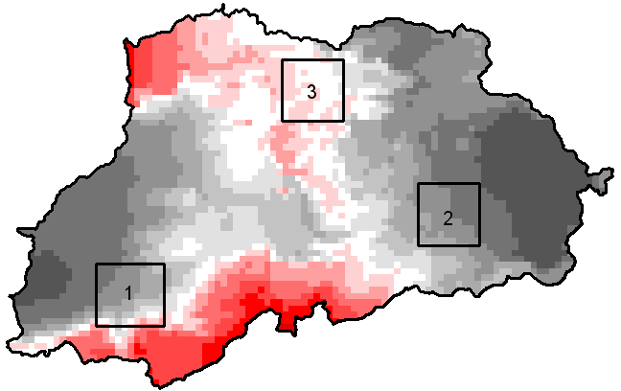

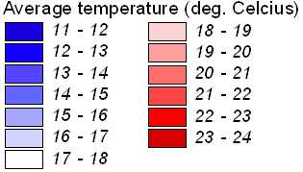
b. Average Annual Temperature (ºC)
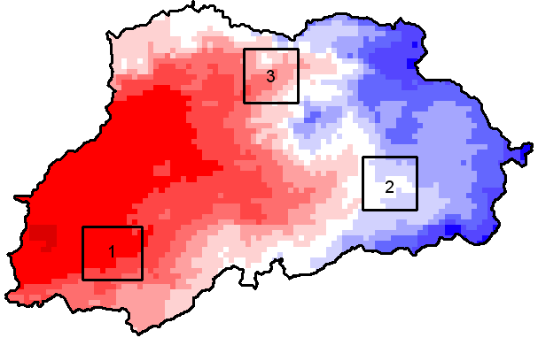

c. Number of consecutive dry months
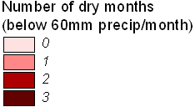
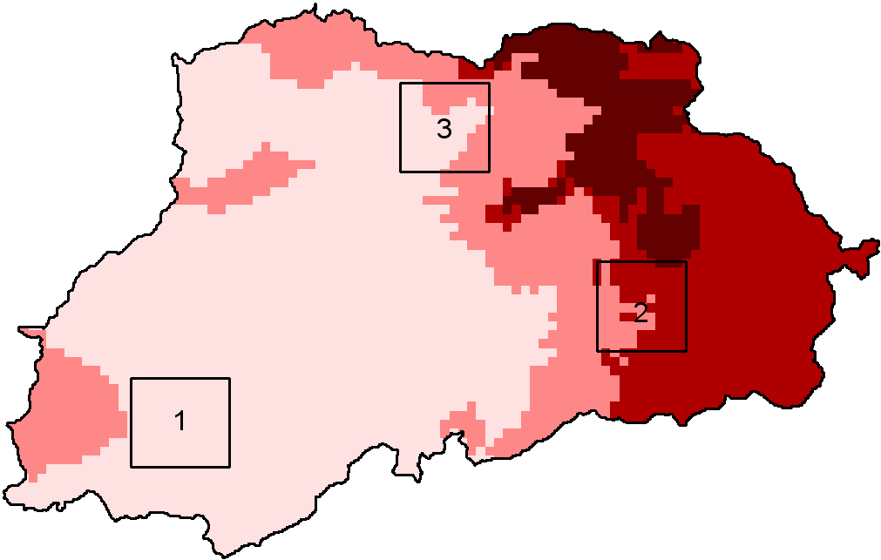
Source: WorldClim (Hijmans, 2004)

Figure 8. (a.) Digital Elevation Model (DEM) of the Nyando study area, interpolated from a 1:50,000 contour map and (b.) a slope map derived from the DEM.

a. Digital Elevation Model (m asl)

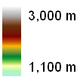
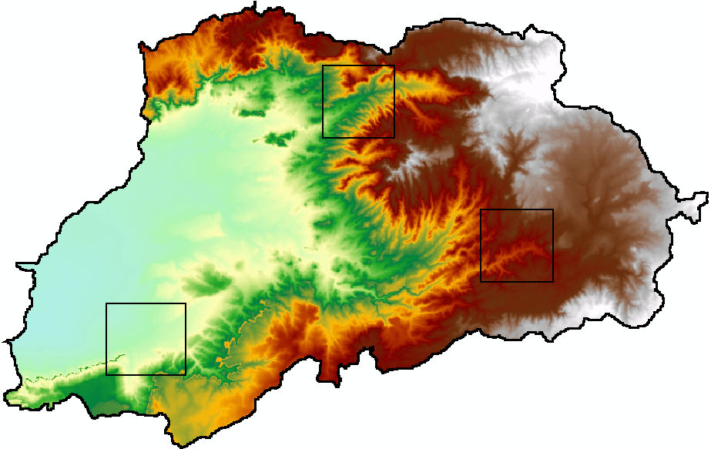

Figure 16: Growth and yield curve estimation, and aboveground carbon accumulation, for six proposed tree species.

a. Growth and Yield Curves

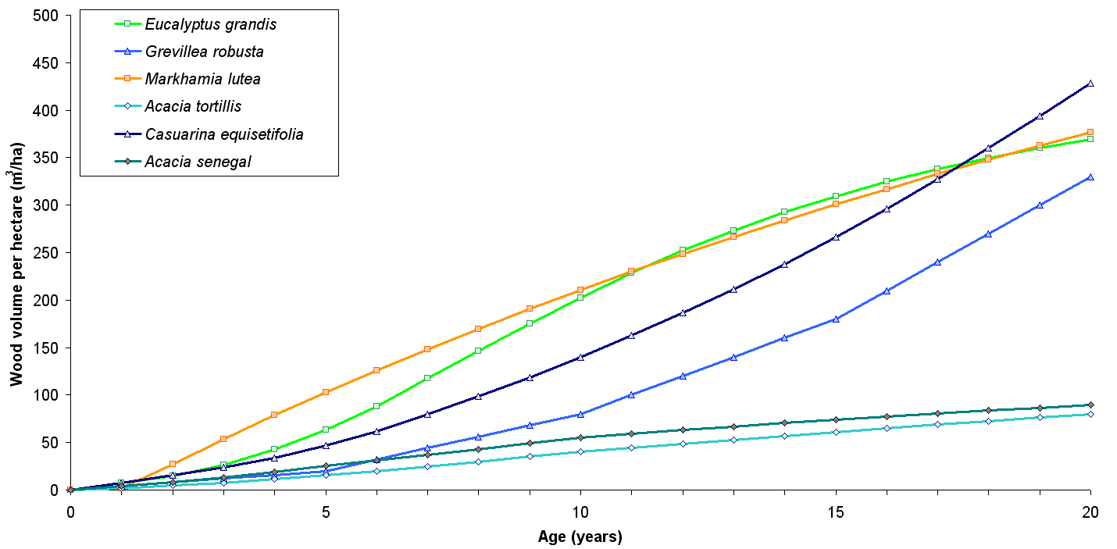
b. Aboveground Carbon Accumulation
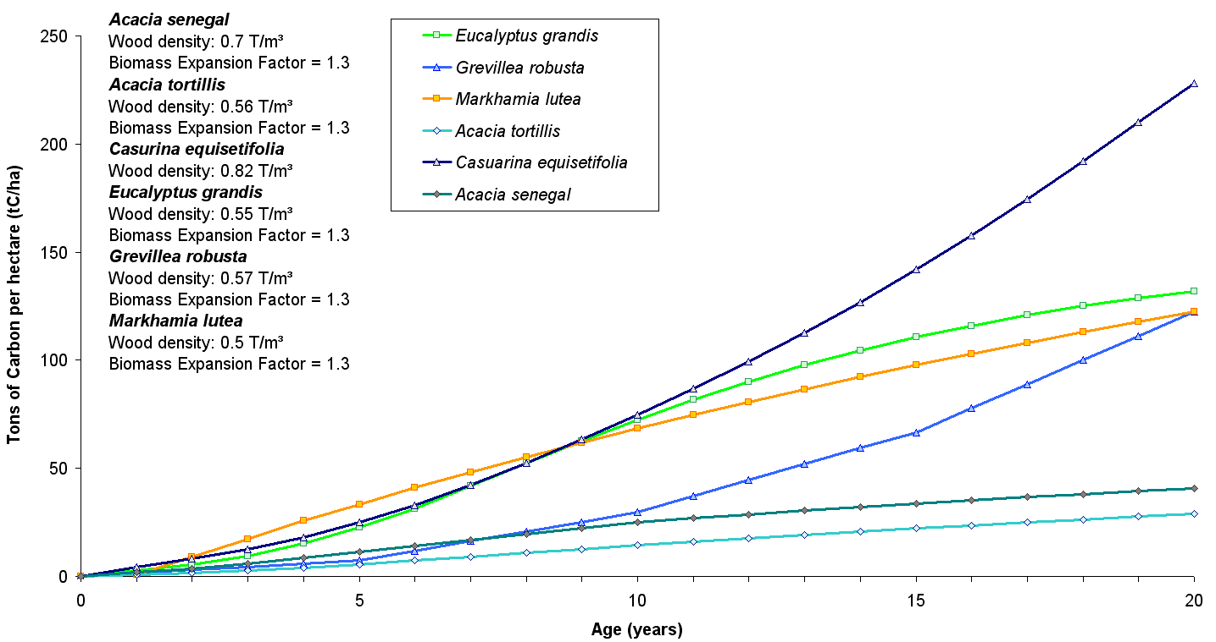

Figure 17: Estimated carbon accumulation and average carbon stock for six proposed tree species growing in the Nyando watershed project area

a. Acacia senegal

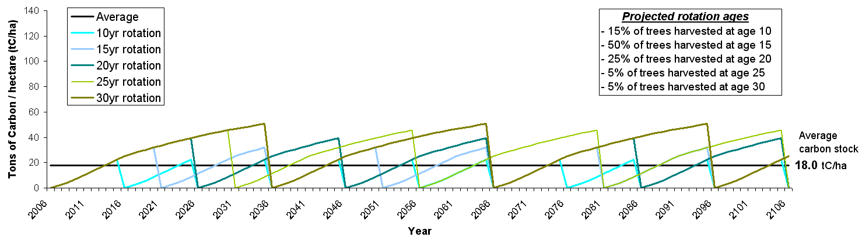
b. Acacia tortilis

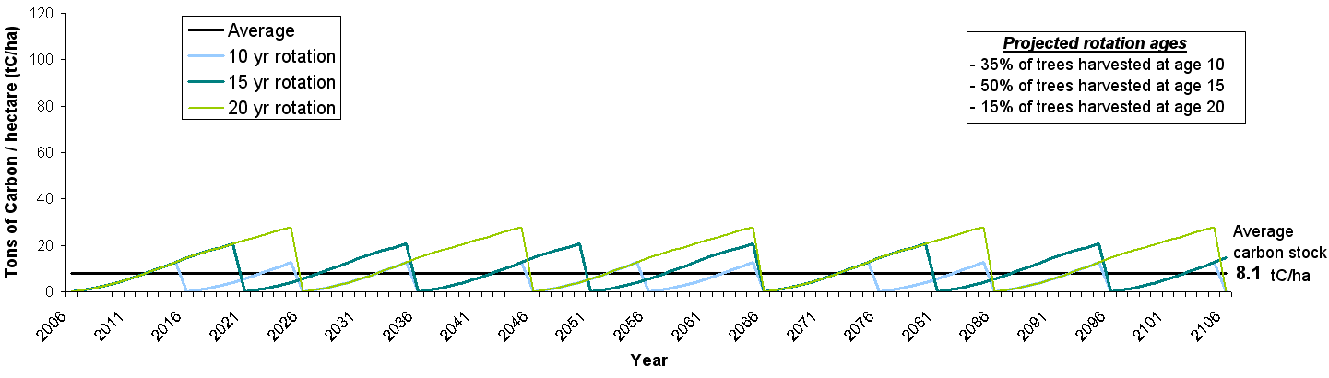
c. Casuarina equisetifolia
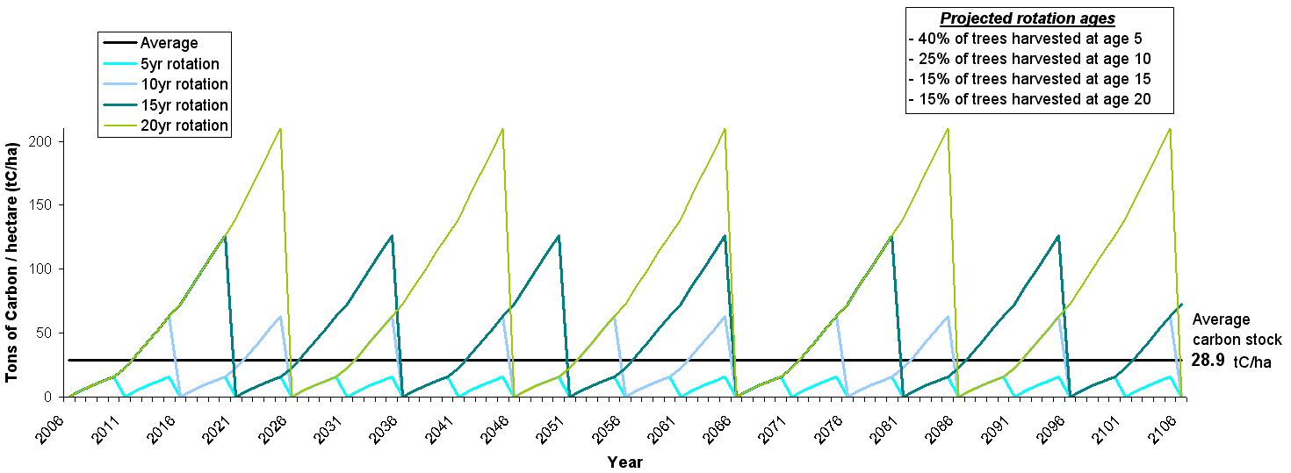

d. Eucalyptus grandis
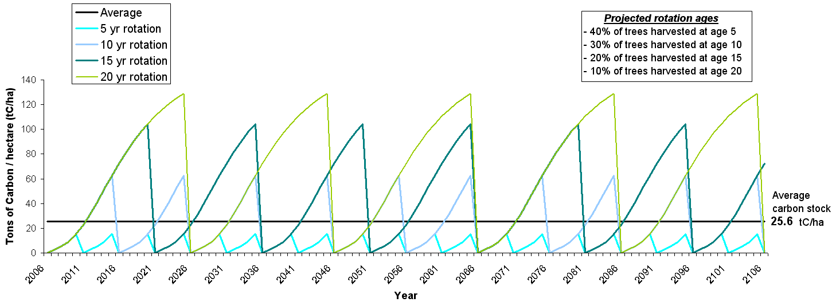

e. Grevillea robusta

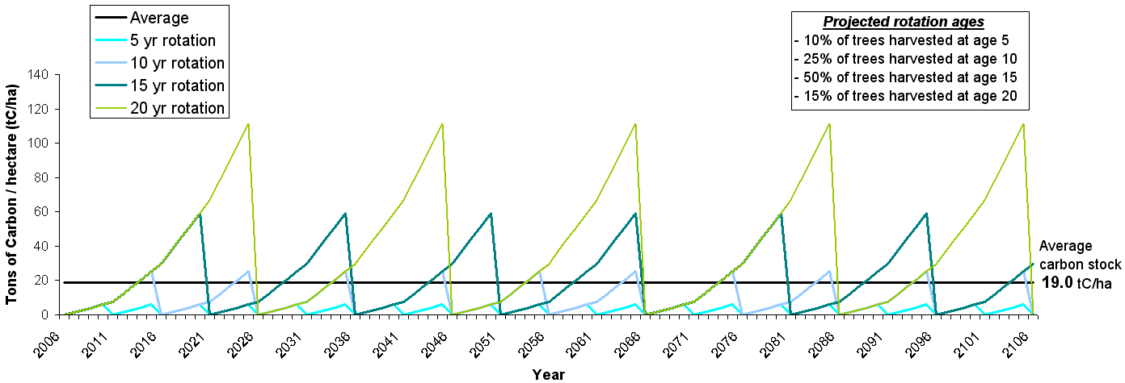

f. Markhamia lutea
