Lower Nyando monthly report June 2008
By Joash Mango and Isaac Learamo

The following activities took place during the month of June;

- Land cover classification
- Support of rehabilitation and follow up of planted tree and fruits through food for work
- Follow up of onfarm trials, woodlots and fodder plots

Land cover classification

This exercise took place between 12th and 17th June 2008 in Lower Nyando of which 21 points was georeferenced and vegetation cover classified to access land cover change within the block.

Follow up of rehabilitation sites and onfarm trials

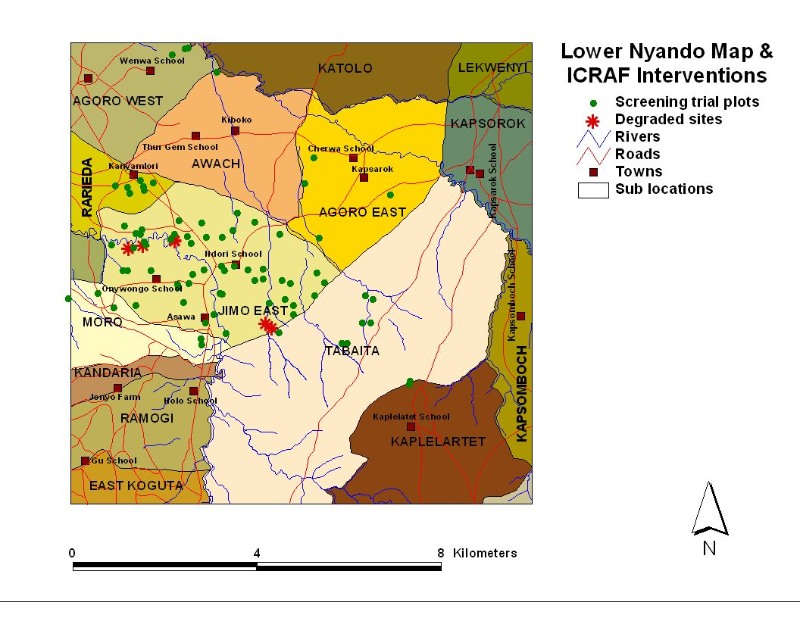

Follow up of onfarm trials, rehabilitation sites and fodder banks took place within the month of June 2008
Observations

The rehabilitation sites are moderately healing with return of up to 80% ground vegetation cover which drastically decreased the surface runoff during the rains. Regeneration of natural shrubs and trees is also taking place. Good stand of natural grasses have covered some water ways, gulley’s head which were previously bare and eroded. Most of the planted indigenous trees have survived and are performing well mainly; Acacia polycantha, Acacia perciflora, Acacia Senegal and Albizia species.
The exotic trees performing well are; Grevellea robusta and Casuarina equistiflora.
The two rehabilitation sites which are doing very well are Kokoto and Kalacha;

- Kokoto rehabilitation site

The following trees seedlings were planted in the long rains of 2008;
Acacia mellifara 1000
Acacia xanthophlea 600
Albizia spp 200
Acacia albida 900
Grevellea robusta 100
The seedlings are doing well with the management of the community through food for work approach. The community group has extended the rehabilitation site to cover the up most part of the area of which additional seedlings are needed for planting during short rains of 2008.

- Kalacha rehabilitation site

The following fruits trees were planted as per the mid term review proposal to at least have first growing for early benefit to the community 20 grafted Mangoes. The community group is being supported to construct hay storage house as they have been harvesting grass but going to waste due to lack of proper storage. The management of the planted fruits trees is going on well.

The following rehabilitation sites are coming up slowly with management of communities and support of ICRAF staff through technical advice.

- Kowalla rehabilitation site

The following trees seedlings were planted in the long rains of 2008;
Acacia mellifera 1600
Acacia polycantha 500
Acacia mellifera are mainly planted along boundaries as live fence to curb the free grazing issue in the area and also as demarcation for land between each individual. The community has liked it as it established quickly and have good fence of which livestock’s or human being cannot pass through it.

The fodder bank has established very well within the group members as some of them have started harvesting of the seeds for multiplications. The main issue with the fodder is lack of improved livestock to be feed by the fodder as the community need either improved livestock or up grading of the existing ones to minimize the number of stock per household as these will minimize erosion caused by livestock.

- Kokumu rehabilitation site

This is anew group which started one year ago through advice of Kowalla group in order to create a buffer zone along Asawo River. The following seedlings have planted in the long rains 2008; Acacia mellifara 500, Acacia polycantha 600 with no support from ICRAF but meeting have been convened to start supporting the group with the new grant.

Conclusion

There is need to support the Kalacha group with hay making machine to minimize the loss they are experiencing. Up grading of the livestock within the community is needed in order to minimize the numbers of which will reduce the erosion caused by numbers. Introduction of live fencing should be encouraged as it is cheap and easy to establish.

