Baseline Report
Yala and Nzoia River Basins

Western Kenya Integrated Ecosystem Management Project
Findings from the Baseline Surveys

Compiled by: Anja Boye
Louis Verchot
Robert Zomer

With technical support from:

Luka Anjeho Tom Ochinga
Isaac Learmo Joash Mango
Donald Agwa Odhiambo Florence Muchoki
Meshack Nyabenge Peter Okoth

International Centre for Research in Agorforestry
Nairobi, Kenya
5 April 2008



Table of Contents

1. Introduction 1
1.1 Aim and objectives 1
1.2 Introduction to the Yala river basin 1
2. Baseline data collection 2
2.1 Sampling design 2
2.2 Sampling methods 2
2.2.1 Socio economic sampling methods 2
2.2.2 Biophysical sampling methods 3
3. Lower Yala 6
3.1 Biophysical baseline data summary 6
3.1.1 Topography 6
3.1.2 Soil texture and soil depth restrictions 8
3.1.3 Vegetation and land use 9
3.1.4 Soil erosion and conservation measures 11
3.2 Socio economic baseline data summary 12
3.2.1 Household parameters 12
3.2.2 Land use and livestock 14
3.2.3 Major constraints at farm level 14
3.2.4 Soil and water conservation 15
3.2.5 Trees & Agroforestry 15
3.2.6 Household energy supply 16
3.2.7 Trainings and group membership 17
3.3 Management Recommendations 17
4. Middle Yala 21
4.1 Bio physical baseline data summary 22
4.1.1 Topography 22
4.1.2 Soil texture and soil depth restriction 23
4.1.4 Soil erosion and conservation measures 25
4.2 Socio economic baseline data summary 27
4.2.1 Household parameters 27
4.2.2 Land use and livestock 28
4.2.3 Major constraints at the farm level 29
4.2.4 Soil and water conservation 30
4.2.5 Trees and Agroforestry 30
4.2.6 Household energy supply 31
4.2.7 Training and group membership 32
4.3 Management recommendations 32
5 Upper Yala 37
5.2 Biophysical baseline data summary 38
5.2.1 Topography 38
5.2.2 Soil texture and soil depth restrictions 39
5.2.3 Vegetation and land use 40
5.2.4 Soil erosion and conservation measures 41
5.3 Socio economic baseline data summary 44
5.2.1. Household parameters 44
5.2.2. Land use and livestock 45
5.2.3 Major constraints at farm level 46
5.2.4 Soil and water conservation 46
5.2.5 Trees & Agroforestry 46
5.2.6 Household energy supply 47
5.2.7 Trainings and group membership 48
5.3 Management Recommendations 48
6. Lower Nzoia 53
6.1 Biphysical baseline data summary 54
6.1.1 Topography 54
6.1.2 Soil texture and soil depth restrictions 55
6.1.3 Vegetation and land use 56
6.1.4 Soil erosion and conservation measures 58
6.2 Socio economic baseline data summary 59
6.2.1 Household parameters 59
6.2.2 Land use and livestock 61
6.2.3 Major constraints at farm level 61
6.2.4 Soil and water conservation 62
6.2.5 Trees & Agroforestry 62
6.2.6 Household energy supply 63
6.2.7 Trainings and group membership 64
6.3 Management Recommendations 64
7 Conclusion 68

Introduction

1.1 Aim and objectives

The first aim of the WKIEMP baseline reports are to synthesize a quantitative description of the baseline project situation along the ecological and socioeconomic dimensions that are relevant for project implementation. In this context, flexible strategies for selecting priority intervention areas and households at the landscape/population scale are proposed. The second aim is to lay a foundation for change detection that considers spatial variability explicitly.

1.2 Introduction to the Yala river basin
The Yala River Basin covers an area of 3,351 km² and the Yala River is one of the main Kenyan rivers draining into Lake Victoria. Average discharge is 27.4 m³/s, with a total N content of 1000 tonnes per year and total P content of 102 tonnes per year.

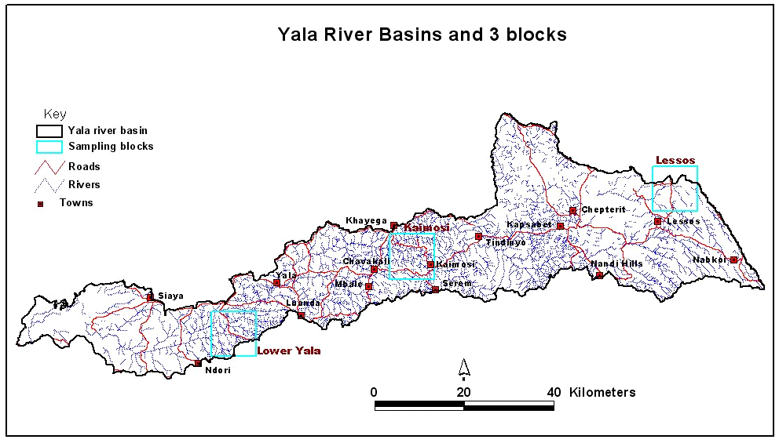
The Western Kenyan Integrated Management Project (WKIEMP) has identified three main areas in the Yala River Basin in which activities will take place. These focus areas (or “blocks”) have been identified from ground surveys and satellite images and have been placed to represent the basin in terms of elevation, slope, rainfall regimes and land use: the Lower Yala block is located in an area with high population density and moderate slopes; the Middle Yala block further upslope characterized by higher elevation, moderate to steep slopes and less erratic rainfall and finally, the Upper Yala block characterized by larger farms and higher elevation.
Map of the Yala River Basin showing the 3 blocks

Baseline data collection
Baseline data was collected for socioeconomic and biophysical parameters. Before commencing the baseline data collection, the local administration was informed of the project and a series of meeting arranged in each of the sub-locations where sampling was to take place. KARI and ICRAF jointly hold these meetings, where the overall objectives of the project were outlined and discussed.

Sampling design
The baseline data collection is built around the use of blocks of 10 × 10 km in size. The basic sampling unit is called a cluster. In each block, 16 centre points are generated from which 10 sampling plots that constitute the cluster are generated. Hence, in each block the sampling size is 160 plots (see map in section 3.1). The centre point of each cluster is randomly placed within each block. The sampling plots are then randomized around each cluster centre point, resulting in a spatially stratified sampling design. This sampling design ensures proportional sampling within each block and minimizes local biases. The randomization procedures are done using either customized programs or scripts or a special Microsoft Excel spreadsheet that has been prepared for this purpose. Using these tools enables easy up-load of plot coordinates to GPS units, which are then used to navigate from sampling plot to sampling plot in the baseline data collection exercise. For more detailed information about the randomization procedure see Annex 1, p.4 or the Biophysical and Socioeconomic Monitoring and Evaluation Plan.

Sampling methods

Socio economic sampling methods
Socio economic information is collected on a household level by the use of a questionnaire designed by KARI and ICRAF. The questionnaire contains 63 questions regarding various socio economic parameters such as household size and economy, livestock, soil and water conservation, agroforestry, etc. Three enumerators carry out the survey. They interview 10 households per cluster and collect one soil sample per household, (i.e. sample size is 160 households). A soil sample is collected to i) assess topsoil fertility at farm level and to ii) increase the number of soil samples collected per block to enhance the modelling of soil parameters. The soil samples are dried, crushed, and sieved through a 2mm sieve before being sent to ICRAF Nairobi for further analyses. See section below for more detailed description of analyses for soil samples. The information from the questionnaire is then entered into a Microsoft Access database created by ICRAF, which enables easy queries of data. The questionnaire is attached in Annex 2.

Biophysical sampling methods
Biophysical information is collected for each of the 10 sampling plots for the 16 clusters. The biophysical team collects information on soil infiltration capacity, land forms and land cover, and soil characteristics. Before sampling can begin, the sample plot needs to be laid out.

Plot lay out
Upon reaching the sampling plot, the radial arm plot method is used in setting up the plot layout as described on p.5 in Annex 1. This method allows soil and vegetation to be sampled and classified for an area of 1000m². After identifying the centre point (point no. 1) an additional three points are set up in the following order: sample point no. 2 is placed 12.2 m up-slope from the centre point, where point no. 3 and 4 are off-set 120º and 240º, respectively from the centre point in the down slope direction. Once the plot layout is set-up, sampling can begin.

Data collection
The field data recording sheet is given on p.10 in Annex 1. The recording sheet is divided into six sections, A-F:
Section A: First, the centre point location is geo-referenced using a GPS unit. Thereafter, slope is measured both up and down slope using a clinometer.
Section B: Second, the major land forms and the topographic position are described. To do this, the surrounding area is inspected and the appropriate categories, provided on the field data recording sheet, are selected.
Section C: Thereafter, the land cover for all four points is recorded using the FAO Land Cover Classification System (LCCS). This classification system recognizes 8 primary land cover types of which 5 are present in the study areas of WKIEMP: Cultivated and managed terrestrial areas, natural and semi-natural vegetation, cultivated aquatic or regularly flooded areas, natural or semi-natural aquatic or regularly flooded vegetation, and bare areas. The LCCS classification system allows the identification of different land cover types on the basis of the dominant vegetation type (tree, shrubs, herbaceous). The questions in the field data recording sheet are designed to guide one through the classification process.
Section D: In section D, we collect information is regarding land use and land ownership.
Section E: Section E is for characterization of the soil surface. The first questions are on erosion and conservation. Thereafter, soil sampling at the four points is carried out. Topsoil is sampled for the 0-20 cm depth and subsoil for the 20-50 cm depth by using a soil auger. The soil samples are bulked for the two depths in separate bags. Soil depth is measured until a depth of 120 cm at 5 cm increments and the depth of restriction is indicated on the field recording sheet.
Soil texture is assessed by using the ribbon method. The method is widely used for quick assessment of texture and is also the recommended method by the Australian Gas office. Instructions for this method can be found on p. 6 in Annex 1.
Section F: Woody vegetation is measured in this section using the T-square sampling method. This method is one of the most robust methods for sampling woody plant communities. It can be used to estimate stand parameters such as density, basal area, bio-volume, and biomass. The advantage of this method is that it is less prone to bias where plants are not randomly distributed, such as in managed landscapes. In this sampling scheme, trees and shrubs are sampled separately. See the guide given on p. 7 in Annex 1 for a more detailed description of the woody vegetation measurements.

Soil infiltration capacity
Infiltration measurements are carried out at 3 of the 10 sampling plots for each of the 16 clusters. Infiltration rings measuring 12 inches in diameter are placed at the centre point (point no. 1) and infiltration rates are measured after the soil has been pre-wetted with approx. 2-3 litres of water. The data sheet is given on p. 12 in Annex 1.
The infiltration data is then entered into the Microsoft Access database designed for the biophysical baseline survey and infiltration curves are fitted using the Hortonian infiltration function.

Soil analyses
The soil samples collected from both baseline surveys are air dried for a minimum of 3 days at the ICRAF Kisumu soils laboratory. The dried soil samples are crushed and sieved through a 2mm sieve and sent to Nairobi for further analyses. Samples are first analyzed using infrared spectroscopy and a subset of samples is sent to the lab for further analysis to permit calibration of the spectral data to soil properties of interest.
After completing the data collection, data is entered into the Access database designed for the bio physical baseline survey. This data together with the entered data from the socioeconomic survey is the basis of this report.
      - Current status of baseline data collection
In the Nyando river basin, the collection of baseline data is nearing completion. The lower block has been sampled and a draft baseline report has been written and shared with KARI (Dec. 2006). As for the two other blocks, the socio economic surveys have been completed for the middle block and the survey is taking place for the upper block. The biophysical team is collecting data for middle block and will thereafter move into the upper block.

Lower Yala
The Lower Yala block is located in Kisumu and Siaya Districts. The block contains twelve sub-locations. This block is characterized by low to medium gradient hills, with shallow depressions and small permanent streams. The Yala River traverses the block from northeast to southwest.

The population is largely Luo, but there are areas where Luhya predominate. The area is largely subsistence farming today with a mix of crops typical of the lower elevations of western Kenya. Maize and sorghum are the major crops; banana and cassava are also grown. The area is also an important producer of mangos.
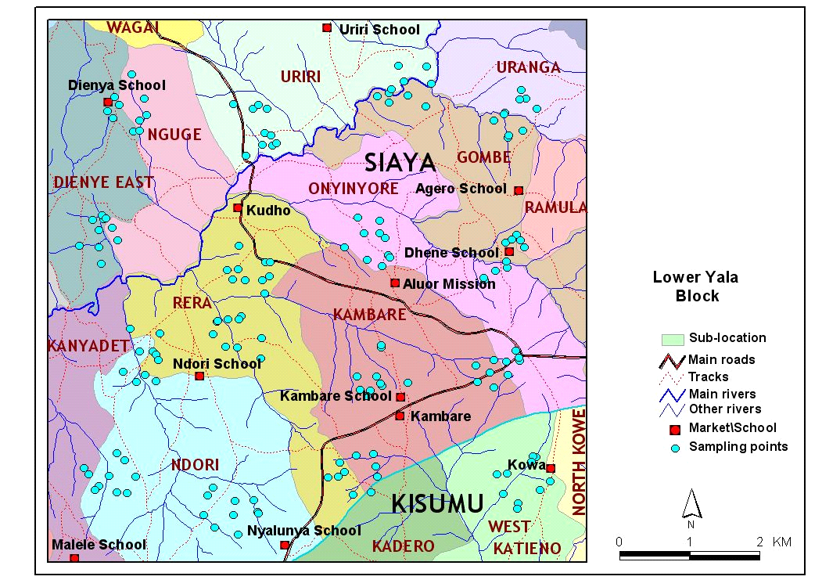

Figure 3.1. Administrative map of the Lower Yala block. The blue dots are the sampling points for the biophysical survey.

Biophysical baseline data summary

Topography
The area Lower Yala is generally characterized by moderate to steeply sloping terrain with slopes ranging between 1 and 35%. The northern part of the block has a few large hills, notably Nguge Hill in the northwest corner of the block (Figure 3.2). The central and southern parts of the block have a rolling terrain. The Yala River traverses the block from the northeast to the west. The block is dissected by a number of important tributaries of the Yala, including the Ogommo Nyanyo and the Dhoneno Rivers.

Around 35% of block area is flat with slopes of less than 5% (Table 3.1). Moderate to steep slopes (> 10%) cover 22% of the block. The areas around clusters 4, 12 and 16 are hillier, with slopes exceeding 10%. The eastern part of the block also has more sloping land with 30 to 40 percent of the plots in clusters 14 and 15 exceeding 10% slope. Cluster 8, between clusters 4 and 12 fell on the Yala River flood plain in Uriri sub-location.

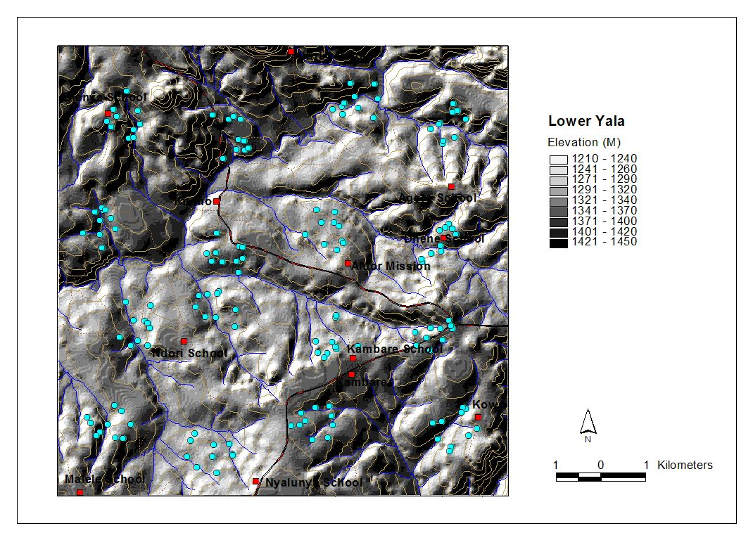
Figure 3.2. Topographic map of the Lower Yala block showing streams, rivers and sampling points.

Table 3.1. Average slope, slope range and incidence of steep slopes
Cluster | Average slope  (%) | Slope range  (%) | No. values > 10%
1 | 8.71 | 1.7 – 19.4 | 3
2 | 3.9 | 0 – 12.3 | 1
3 | 6.17 | 3.1 – 7.9 | 0
4 | 14.06 | 4.4 – 34.4 | 6
5 | 4.73 | 3.1 – 7.0 | 0
6 | 6.47 | 1.7 – 11.4 | 2
7 | 5.21 | 2.2 – 11.4 | 1
8 | 4.97 | 1.7 – 10.1 | 1
9 | 6.52 | 3.1 – 11.4 | 1
10 | 5.83 | 3.1 – 12.7 | 1
11 | 6.17 | 1.3 – 10.5 | 2
12 | 16.65 | 5.2 – 30.6 | 8
13 | 6.44 | 2.6 – 8.3 | 0
14 | 8.9 | 1.7 – 18.5 | 4
15 | 8.02 | 1.7 – 15.8 | 3
16 | 8.55 | 3.9 – 21.3 | 2

Soil texture and soil depth restrictions
The soil texture in this area is mainly clay loam (Table 3.2). The soils of the eastern part of the block are somewhat lighter textured than the western part of the block, with a higher presence of sandy and silty clay loam soils. Clay soils were associated predominantly with mid-slope sites and some bottomlands.

Table 3.2. Soil texture (% of samples).
Clay | Clay loam | Sandy clay loam | Sandy Loam | Silty clay | Silty clay loam | Loam | Sand
8 | 45 | 12 | 7 | 7 | 19 | 1 | 1

Soil depth restrictions were widespread across the block, with 39% of the subplots sampled showing restrictions within the first 50 cm and 20% of the subplots showing restrictions within the first 20 cm. Clusters 1, 2, 11 and 14 had very high incidence of depth restriction. Clusters 3, 13 and 15 had relatively low incidence of depth restrictions.

Table 3.3. Incidence of depth restrictions per cluster
(values = % of subplots per cluster with depth restrictions; n = 640).
Cluster | Shallow (≤ 20 cm) | Deep (> 20 cm)
1 | 40 | 58
2 | 18 | 56
3 | 10 | 8
4 | 33 | 20
5 | 15 | 10
6 | 23 | 8
7 | 15 | 13
8 | 5 | 25
9 | 28 | 10
10 | 18 | 10
11 | 48 | 15
12 | 20 | 18
13 | 5 | 13
14 | 30 | 30
15 | 5 | 8
16 | 13 | 0

Vegetation and land use
Farming is the major land-use and drives land cover in the block (Table 3.4). Agriculture is dominated by cereal production, but there are also areas with perennial grasses for livestock grazing. There are small areas of woodland along the Yala River. Much of the land around Cluster 5 is fallow or abandoned scrub land. The project should look closely at this area for rehabilitation. The second most common vegetation type was grasslands. Natural grass species includes both perennial and annual both palatable and unpalatable for livestock. The dominant species in the area are:
- Cymbopogon comphanatus: perennial grass, moderate to high forage quality;
- Sporobolus pyramidalis: annual grass; low forage value;
- Digitaria ciliaris: annual grass; low forage value;
- Digitara gazensis: perennial grass; high quality forage
- Eragrostis aspera: annual grass; moderate forage quality;
- Eragrostis superba: perennial grass; good quality forage;
- Hyparrhenia collina: perennial grass; good forage, but it should be stocked in the early stages of growth.
Table 3.4. Land cover classification (N = 160)
Vegetation strata | No. points | Percentage
Fallow | 28 | 17.5
Farm land | 73 | 45.6
Forage land | 9 | 5.6
Other | 1 | 0.6
Perennial grassland | 36 | 22.5
Shrub land | 12 | 7.5
Woodland | 1 | 0.6

The largest allocation of land in this block was for grazing livestock. The area used for crop production was somewhat less. Notably, food production was largely absent in clusters 4 and 11, but grazing was the dominant land use in these clusters. A small percentage of the land was used primarily for producing wood. A classification of the primary current land use showed the following:

Food / beverage: 43%
Forage: 55%
Timber / fuel wood: 12%
Other: 4%

In general there are few trees in the landscape. No woodlots or planted plantations were found during the survey. Of the 160 plots sampled only 28% or 45 plots had trees in the vicinity. This woody vegetation is mostly broadleaf and evergreen, (Table 3.5).

The woody vegetation present in this area is broadleaf and evergreen. Markhamia lutea was the tree most commonly encountered. Terminalia brownii, Psidium guajava and Senna spectabilis were also commonly seen. There was a wide variety of shrubs encountered including Rhus vulgaris, R. natalensis, Lantana camara, Carissa indulis and Tithonia diversifolia. Shrubs were widely present in the landscape and were measured on 82% of the plots. Few exotics were found on the plots sampled. Ipomea was widespread in this block indicating low soil fertility.

Table 3.5. Wood vegetation type (% of plots with vegetation types present)
Broadleaf | Needle leaf | Allophytic | Evergreen | Deciduous
83.8 | 0.0 | 1.3 | 76.3 | 6.9

In this block all farms surveyed are privately owned and for 28% of the plots land use has not changed since 1990. However it was impossible to ascertain whether land use has changed for the majority of the plots (59%).

Soil erosion and conservation measures
Soil erosion was visible in 57% of the plots, with highest incidence in clusters 1, 4, and 6. Because of the presence of sodic soils on the lake plains in this block, presence of erosion does not always correspond with steep slopes. Clusters 10, 11 and 16 had the lowest incidence of soil erosion. The principal type of erosion is sheet erosion, but rill erosion was more common in this block than what has been seen in other blocks of the Yala River basin (especially clusters 4 and 11). Table 3.6 indicates on a cluster basis, the percentage of points showing visible signs of erosion.

Soil and water conservation is practiced in this block, but needs to be expanded. The clusters with the highest incidence of erosion were not the areas where most of the erosion control structures were encountered. Nevertheless, soil conservation structures were found in all but three clusters within the block. Therefore, the project can build on current practices and extend soil and water conservation practices. This should be done in association with tree planting should be one of the first activities undertaken in this block.

Table 3.6. Percent of plots showing erosion features for each cluster
Cluster | None | Sheet | Rill | Gulley
1 | 0 | 100 | 0 | 0
2 | 40 | 50 | 10 | 0
3 | 60 | 40 | 0 | 0
4 | 10 | 60 | 30 | 0
5 | 30 | 70 | 0 | 0
6 | 0 | 90 | 10 | 0
7 | 50 | 50 | 0 | 0
8 | 60 | 40 | 0 | 0
9 | 50 | 50 | 0 | 0
10 | 80 | 10 | 10 | 0
11 | 70 | 10 | 20 | 0
12 | 40 | 50 | 10 | 0
13 | 40 | 50 | 10 | 0
14 | 40 | 60 | 0 | 0
15 | 50 | 50 | 0 | 0
16 | 70 | 30 | 0 | 0

Table 3.7 Summary of baseline parameters
Cluster | Texture | Slope (%) | Woody vegetation cover* | Soil depth restriction  (%) | Soil erosion (%) | Household size
1 | Sandy clay to clay loam | 8.71 | Low | 98 | 100 | 5
2 | Clay to sandy clay | 3.9 | Low | 74 | 100 | 5
3 | Clay loam | 6.17 | Moderate | 18 | 100 | 5.9
4 | Sandy clay loam | 14.06 | Moderate | 53 | 100 | 5.1
5 | Clay loam | 4.73 | Moderate | 25 | 100 | 8.5
6 | Clay loam | 6.47 | Moderate | 31 | 100 | 5
7 | Silty clay loam | 5.21 | Moderate | 28 | 100 | 5.4
8 | Silty clay loam | 4.97 | Low | 30 | 100 | 8.4
9 | Clay loam | 6.52 | Moderate | 38 | 100 | 5.2
10 | Clay | 5.83 | Low | 28 | 100 | 5.3
11 | Clay loam | 6.17 | Moderate | 63 | 100 | 7.2
12 | Clay loam | 16.65 | Low | 38 | 100 | 6.2
13 | Silty clay | 6.44 | Low | 18 | 100 | 7.1
14 | Clay loam | 8.9 | Low | 60 | 100 | 6.3
15 | Clay loam | 8.02 | Low | 13 | 100 | 8.9
16 | Sandy clay to clay loam |  | Low | 13 | 100 | 6.8
* Low: <15%; Moderate: 15 to 65%, High: > 65%.

Socio economic baseline data summary

Household parameters
Average household size is six people with 89% of the households having 10 members or less (Table 3.8). Only two households have more than 15 members. Population density is highest on the south side of the river (Figure 3.3). Average farm size is 3.9 acres; however, 88% of the households have farm sizes of 4 acres or less. Less than 5% of the households have farm sizes larger than 10 acres (Table 3.9). The majority of the households were male headed (70%), while the rest (25%) were female headed. One household was headed by orphans and only seven households were polygamous.

Table 3.8 Household size (N=161)
Household size | Number in sample | Percentage
3 or less | 33 | 20.5
4 | 17 | 10.6
5 | 20 | 12.4
6 | 17 | 10.6
7 – 10 | 56 | 34.8
11- 15 | 16 | 9.9
More than 15 | 2 | 1.2

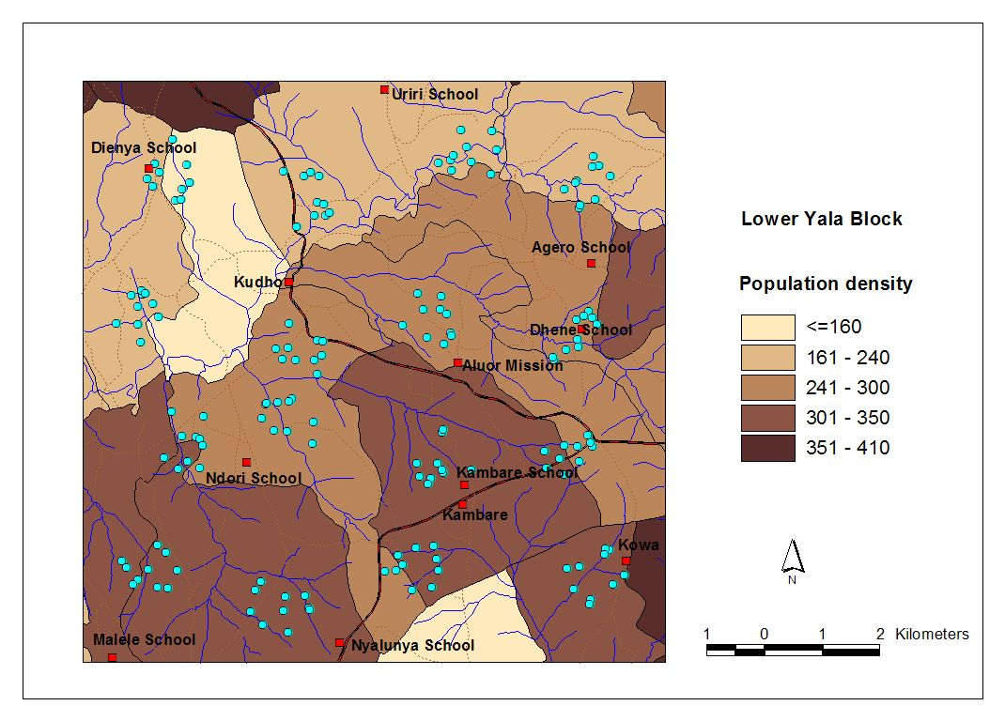
Figure 3.3 Population density in Lower Yala Block

Table 3.9 Farm size (N=161)
Farm size | No. households | Percentage
2 acres or less | 48 | 29.8
3 acres or less | 40 | 24.8
4 acres or less | 22 | 13.7
5 to 9 acres | 44 | 27.3
10 acres or more | 7 | 4.3

Land use and livestock
Of the 160 households surveyed, 156 rear livestock. Table 3.10 lists the percentage of households with different species of livestock. Only one household in the study area had pigs and only seven households had donkeys. Improved breeds are not widely raised in the area. Only three households had improved breed cattle, while no improved goats or chickens were being raised in the households sampled.

Table 3.10. Livestock ownership in percentage (N=161)
No. | Cow |  |  | Chicken |  |  | Goat |  |  | Bull |  |  | Sheep
No. | Local¹ | HB² |  | Local | HB |  | Local | HB |  | Local | HB |  | Local
0 | 46.0 | 98.8 |  | 8.7 | 100.0 |  | 52.8 | 100.0 |  | 60.9 | 98.8 |  | 78.3
1 | 12.4 | 1.2 |  | 3.1 | 0.0 |  | 9.3 | 0.0 |  | 11.8 | 0.6 |  | 5.6
2 | 15.5 | 0.0 |  | 10.6 | 0.0 |  | 18.0 | 0.0 |  | 13.0 | 0.0 |  | 5.0
3 | 14.3 | 0.0 |  | 12.4 | 0.0 |  | 8.7 | 0.0 |  | 4.3 | 0.0 |  | 3.1
>3 | 11.8 | 0.0 |  | 65.2 | 0.0 |  | 11.2 | 0.0 |  | 9.9 | 0.0 |  | 8.1
Highest no. | 7 | 1 |  | 150 | 0 |  | 15 | 0 |  | 11 | 1 |  | 9
¹Local indicates local breed, ²HB indicates improved breed

The source of fodder is mainly grasses (71%) and crop residue (56%). Average acreage used for crop residue production is 1.8 acres and livestock grazes on around 1.7 acres, on average. Grazing on communal land is common (32%) and uncommon on government land (2 cases). Commercial feed is a source of fodder for only 15 households and only 2 households buy feed at the local market. However, 83% of the households are experiencing problems with their livestock. The major problem is livestock health, with 98% of the respondents reporting problems with ticks and with disease incidence. Only 9% of the households cited fodder availability as a major problem with their livestock. However, 77% say they do not have adequate land for grazing their livestock, and 61% experience problems with free-grazing livestock from neighbours, which corresponds well with the fact that 63% of the households practice free-grazing.

Major constraints at farm level
The largest constraints at farm level are lack of income and the high prices for inputs (Table 3.11). Farmers also listed financial resources – income and input costs – as major constraints to their farming enterprises. Fertilizer was often cited as a desired input. Soil related problems, particularly erosion were also important. Thus, the project should pay attention to soil erosion and fertility problems in this block. Old age and ill health were cited by a larger number of farmers than in other blocks in the river basin. Linking farm production to improved nutrition should be explored by the Project. Striga infestation and unpredictable weather were also seen as important constraints. Given the close relationship between Striga infestation and soil fertility, this is an area where the Project needs to pay attention.

Table 3.11. Major constrains at farm level listed by farmers
Constraints | No. 1 (N=161) | No. 2 (N=142) | No.3 (N=99)
Input costs | 42 | 20 | 14
Income | 34 | 28 | 11
Erosion | 3 | 26 | 16
Old age/ill health | 24 | 12 | 6
Striga | 18 | 7 | 17
Pests | 3 | 10 | 16
Weather | 8 | 14 | 5
Soil fertility | 10 | 6 | 4

Soil and water conservation
Soil erosion is being addressed by 112 of the households interviewed (71%) and the most common conservation measures are terraces (50%) and strips of grass and shrubs (16%). Here the most common species are local grass species and Napier grass. Of the 66 farmers using terracing as a conservation measure, three farmers have constructed ‘Fanya chini’ terraces. Eleven farmers have established contour lines twenty three have installed physical barriers (stones or contour ploughing.

In addition to these measures, 39 farmers are also harvesting water, mainly from the roof, for domestic use. Hence there seems to be a need to assess the soil and water conservation measures and assist the farmers in selected better measures and integrating trees and legumes in the control of runoff water and soil erosion. This would simultaneously address the low soil fertility that many farmers are mentioning as one of the largest constraints at farm level.

Trees & Agroforestry
The majority (75%) of the farmers are practicing agroforestry. All of the homesteads sampled have trees which are protected (Table 3.12) and 85 percent of the farmers interviewed are interested in planting more trees, which corresponds well with the farmers’ response to practicing agroforestry. Only 27 farmers out of 161 are not interested in planting more trees, which is mainly due to land size (6 farmers), age and ill health (10 farmers), husband making such decisions (4 farmers) and the farmer feel that he or she has enough trees (3 farmers). Approximately 23% of the farmers interviewed are planning to cut down trees on their farm. Seven farmers from mentioned cultural practices as a hindrance to tree planting.
Table 3.12. Tree species on-farm (N=161)
No. | Tree species | No. farms with the species
1 | Markhamia lutea | 100
2 | Mango | 98
3 | Eucalyptus spp. | 60
4 | Avocado | 36
5 | Cypress | 17
6 | Guava | 15
7 | Grevillea robusta | 10
8 | Jacaranda mimosifolia | 10

Reasons for growing trees include producing fruits, fuel wood, timber and to reduce the negative effects of wind (>75% for each). Thirty-eight percent of the respondents use trees grown on the farm for medicine and 60% grow trees for cash income. Less than 25% of the farmers use trees to produce fodder and address soil fertility. Therefore, the project should organize community training to raise awareness of opportunities offered by expanding the growing or trees and production of other tree products to facilitate better integration of trees into the farming system. Using farmers’ answers to rank the importance of agroforestry products the top 10 uses were:

- Fruits
- Fuelwood
- Timber
- Wind breaker
- Food
- Cash income
- Aesthetics
- Medicine
- Fodder
- Soil fertility

Household energy supply
The main sources of fuel for the farming families in this block are wood and paraffin (Table 3.13). About 75% of the households are not energy self sufficient, which might explain the high number of farmers interested in more tree planting as mentioned above. More than 85% of the interviewed farmers are interested in planting more trees.

Table 3.13. Fuel use by source
Fuel source | Percentage
Wood | 100
Paraffin | 99
Charcoal | 75
Crop residue | 17
Solar | 1

Trainings and group membership
The majority of the farmers interviewed have not received any training. Only 41 of the 161 farmers interviewed have received any type of training; most (35) were members of a group. Many farmers in this area (70%) are of members of groups. There are over 130 groups active in the clusters that were surveyed. Table 3.14 lists the number of croups by cluster. Therefore, there is a good base upon which to build the training program in the block for these groups.

Table 3.14. Examples of community groups in different clusters
Group name | Cluster | Main activity
Kwe gi lamo | 1 | Basket weaving
Kanyasiboki | 5 | Chicken rearing
Karabuor | 6 | Store cereals and sell after sometime
Nyiseme women | 11 | Farming
Aluor self help | 11 | Local chicken rearing, horticulture
Riwruok e teko | 11 | Vegetable farming, sell produce, saving money
Otieno Moyie | 15 | Agricultural production
Aluor cent | 15 | Saving and lending money

Management Recommendations
The greatest amount of abandoned degraded land occurs in the western portion of the Block, particularly around clusters 1, 2, and 4. This area should be the focus for land rehabilitation work. Elsewhere in the block, soils are degraded, but still cultivated. These areas should be targeted for soil conservation and development of agroforestry systems that maintain more permanent vegetative cover. Additional erosion and hard setting on these sites could render them unfit for cultivation.

Interventions in this block should mainly focus on soil conservation and increasing soil cover, boosting soil fertility and enhancing biodiversity. When discussing interventions with communities, farm size and soil depth restriction need to be considered. Average farm size is 4.3 acres, which is considerable smaller than elsewhere in the river basin. More than 30% of the sampled points have soil depth restriction at 20 cm, hence it is important that soil depth is assessed before any activity is planned and implemented.

Soil erosion and hard setting is a major problem in this block and baseline data shows severe land degradation in the entire block, except for the river valleys (cluster 3). Hence, activities which halt the degradation of areas that are still being cultivated should be given priority. The Project should also promote rehabilitation of degraded areas, particularly in the western portion of the block. Such activities should include tree planting and control of free-grazing. Over 70% of the households practice conservation, and yet the entire block continues to experience soil erosion and large scale runoff. The project should assist the communities to improve soil conservation measures.

The areas adjacent to the tributaries of the Yala River need to be stabilized and interventions set up to protect the river banks. Recommended interventions are improved fallows and other leguminous cover crops such as Dolichos lablab and Mucuna spp. and planting of indigenous trees in riparian buffer zones.

In general, farmers are interested in agroforestry; however, most farmers have planted Markhamia lutea and Eucalyptus spp. and have poor knowledge of other indigenous trees and their purposes. The most common species besides these two are fruit trees, Cupressus spp., Grevillia robusta, and Jacaranda mimosifolia, all exotics. There are a wide range of indigenous trees which are suitable for the area which should be promoted through trainings and meetings with community groups and extension officers. Focus should be on species suitable for timber, fuel, fodder, and soil fertility. In order to successfully increase the tree cover of this block, there is a need to focus on the purposes and benefits of indigenous trees. More than 70% of the farmers are not self sufficient with firewood and under general comments many farmers asked for more knowledge on trees and especially inquired about access to seeds. Hence, there is an interest for tree planting which this project should capitalize on. This can be done through trainings of community groups, by tree planting in screening trials and degraded areas and in schools.

Many farmers cite old age and ill health as a constraint. The project should evaluate the labour requirements of improved practices and assess the appropriateness of the activities given this constraint. The project might also look at the nutrition of the population and find alternative food sources that facilitate balanced nutrient intake.

Striga infestation is an important constraint in the block, but less important than elsewhere in the river basin. Striga weeds grow well on poor soils with low soil fertility. Studies in Western Kenya, by Boye (2005) and Gacheru and Rao (2005), show that relay-cropping maize and beans with improved fallows reduce Striga infestation after a few rotations. At the same time, soil fertility is improved and the farmer has additional benefits from the wood produced by the fallow crop, fodder and firewood.

Many farmers listed erratic rainfall as a major constraint at farm level. The erratic rainfall pattern of Lower Yala is likely to continue and perhaps worsening in the coming years because of climate change. Hence, interventions which increase soil cover and soil fertility, and which promote diversification should be given priority, since these interventions will buffer the variable climatic conditions. Secondly, the few but heavy rains should be harvested in ponds and dams to ensure better water availability throughout the year. Hence, establishment of ponds and dams is another priority activity for the Project.

All households surveyed have livestock; however, 83% of the farmers are experiencing problems with their livestock. A large number of farmers report health problems and the lack of adequate veterinary services in the area. Ticks and tick-borne diseases are a problem in the area. The Livestock Officer of the Project should look into this and liaise with potential service providers to find affordable and appropriate solutions for these farmers. Fodder supply and quality is not as important a problem in this area as it is elsewhere. Free-grazing is a major problem in the entire block and is a threat to tree plangent activities. The project should therefore assist the communities in setting-up by-laws to control free-grazing and promote live fencing. It is imperative that free-grazing is controlled for the project to have any impact in terms of tree planting and rehabilitation of degraded areas. Several Acacia species can be planted as live fences since they are tolerant to browsing. Establishment of fodder banks and the encouragement of hay production might also be considered with communities. If farmers begin controlling grazing, an alternative fodder source needs to be provided. Planting trees at wide spacing (e.g. 4 x 10 m) on degraded sites would allow for both wood and grass production, where the grass could be used to augment fodder availability for farmers. Another option that needs to be explored with communities is intercropping food crops with a legume that can also be used as animal feed. One such system is improved fallows. The legume, Dolichos lablab can also be used as animal feed.

In general, few farmers have improved breed livestock. To upgrade the breeds, the project should introduce hybrid bulls and goats perhaps in collaboration with the Kenyan dairy goat association. Their regional office for Western Kenyan branch is in Mbale. Rotating the hybrid sires in the area and controlling breeding with local bucks will be more cost effective compared to buying individual hybrid animals. However, a rotational system requires more management.

Finally, establishing and strengthening of community groups should also be an activity of the project. Most of the farmers who have received training are members of groups. Yet a significant number of farmers in the area do not belong to groups and have not received training. Also, for the scaling up of successful project activities, well functioning groups are imperative. Furthermore, the problems of flooding in the middle and lower parts of the block are mainly caused by activities up-slope. The link between the farmers up-slope and the farmers down-slope should be made through trainings for groups in both locations.

Lower Nyando
The Lower Nyando block is located in the lake plain (Kano Plains) of Lake Victoria in Nyando and Kericho Districts. Within the block are two divisions, Upper and Lower Nyando and 16 sub-locations (Figure 3.1). The population is predominantly Luo and Kalenjin. The area is largely subsistence farming, with a mix of crops typical of the lower elevations of western Kenya. Maize and sorghum are the major crops; banana and cassava are also grown. The area is also an important producer of mangos.

Bio physical baseline data summary

Topography
The lower block on Nyando block is characterized by three dominant slope zones: lowlands (0-12%: cluster 3, 4, 7, 8, 10, 11, 12, 15, 16), midlands (12-47%: cluster 5, 6), and uplands / escarpments (>47%: cluster 1, 2, 9, 13, 14) slope zones (Figure 3.2). The area around cluster 13 is characterized by an escarpment dividing the lowlands from the highlands of Kericho. Slopes are particularly steep in this part of the block (Table 3.1) The highlands are high potential areas with high productivity levels. Cluster 5, 6, 10, and 14 are located in Tabaita sub-location, which area has relatively dense vegetation with steep slopes (cluster 9 and 10) and many small streams draining into the lowlands. Cluster 5 and 6 are placed at the foot slope of the escarpment and the slopes in this area are gentler. The centre of the block is characterized by plains, which are often flooded. These areas are highly degraded, especially, the areas around the Awach and Asawo Rivers (cluster 7, 8, 11). The western part of the block (cluster 2 and 3) is more sloping with streams draining into the Asawo River. This area has relatively dense vegetation with sparse settlements. Gully erosion is a serious problem in this block, especially around Lekwenyi and Jimo East sub-locations. The area around Thur-gem in Awach sub-location and Rarieda sub-location are also severely degraded.
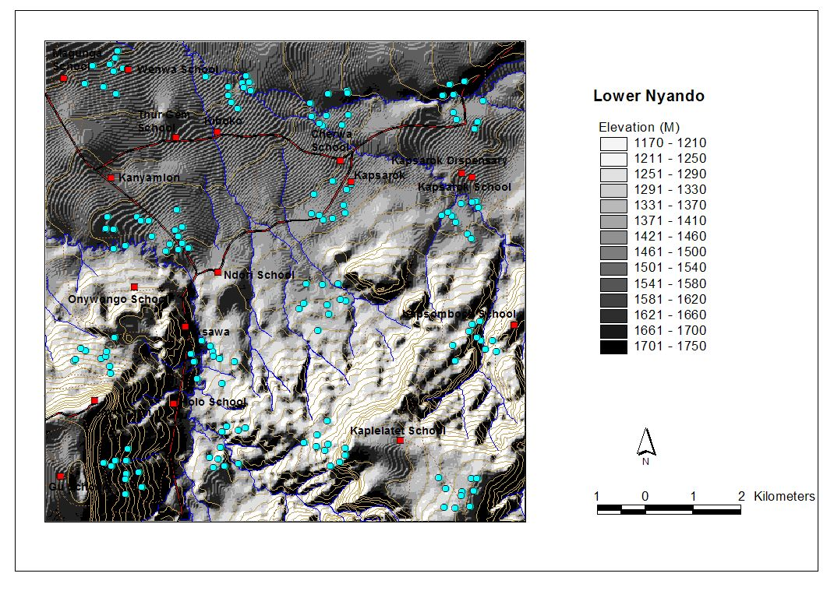
Figure 3.2. Topographic map of lower Nyando block; blue dots indicate biophysical sampling points.

Table 3.1. Average slope, slope range and incidence of steep slopes
Cluster | Average slope  (%) | Slope range  (%) | No. values > 10%
1 | 12.0 | 2.0 – 42.5 | 4
2 | 8.1 | 3.0 – 12 | 3
3 | 1.1 | 0.5 – 1.5 | 0
4 | 1.0 | 0.8 – 1.3 | 0
5 | 4.8 | 1.5 – 7.5 | 0
6 | 3.8 | 2.0 – 6.0 | 0
7 | 1.1 | 0.3 – 2 | 0
8 | 0.9 | 0.25 – 2.0 | 0
9 | 14.1 | 0.5 – 30.5 | 7
10 | 3.4 | 1.5 – 9.0 | 0
11 | 0.8 | 0.25 – 1.5 | 0
12 | 1.0 | 0.0 – 2.8 | 0
13 | 9.6 | 2.5 – 17.8 | 4
14 | 6.2 | 1.8 – 16.5 | 1
15 | 2.3 | 1.0 – 3.5 | 0
16 | 2.2 | 0.3 – 4.5 | 0

Soil texture and soil depth restriction
The soil texture ranges from loamy to clayey. The lowlands have predominantly sandy-clay to silty-loamy soils; the mid slope has clayey and silty-loam soils, whereas the upland zones have predominantly silty to loamy soils. However, there is great variation within each cluster; hence it is important to assess soil texture for the exact locations the project is implementing activities in.

Table 3.2. Soil texture (% of samples).
Clay | Sandy loam | Clay loam | Sandy clay loam | Silty clay | Sandy clay | Silty clay loam | Loam
22 | 22 | 14 | 11 | 10 | 8 | 5 | 5

Soil depth restriction is widely apparent in this block. More than 50% of the locations sampled had soil depth restriction at 20 cm as indicated in the table below, and 67% of the locations had depth restrictions within the first 50 cmSince, soil depth limitation is widespread in this area, it is very important to assess soil depth on specific sites before planning activities, especially activities around agriculture and planting of trees.
Table 3.3. Incidence of depth restrictions per cluster (values = % of subplots per cluster with depth restrictions; n = 40 per cluster).
Cluster | Shallow (≤ 20 cm) | Deep (> 20 cm)
1 | 40 | 18
2 | 48 | 33
3 | 30 | 20
4 | 18 | 8
5 | 50 | 15
6 | 58 | 15
7 | 53 | 35
8 | 75 | 10
9 | 38 | 30
10 | 38 | 13
11 | 20 | 3
12 | 88 | 5
13 | 58 | 10
14 | 78 | 8
15 | 40 | 33
16 | 85 | 13

Vegetation, land use and land ownership
The landscape of the lower Nyando block is dominated by farm and grazing land (52%) and perennial grassland (34%) as indicated in the table below.
Grazing land is the major land-use and drives land cover in the block (Table 3.4). Agriculture is dominated by cereal production, but there are also areas with perennial grasses for livestock grazing. There are small areas of woodland along the Yala River. Much of the land around Cluster 5 is fallow or abandoned scrub land. The project should look closely at this area for rehabilitation. The second most common vegetation type was grasslands. Natural grass species includes both perennial and annual both palatable and unpalatable for livestock. The dominant species in the area are:
- Digitaria ciliaris: annual grass; low forage value;
- Digitara gazensis: perennial grass; high quality forage
- Eragrostis aspera: annual grass; moderate forage quality;
- Eragrostis superba: perennial grass; good quality forage;
- Hyparrhenia collina: perennial grass; good forage, but it should be stocked in the early stages of growth.
- Dactylacteneum spp.
- Bracharia
- Cynodon dactylon
- Capillipedium
- Heteropogon

Table 3.4: Land-cover classification
Vegetation strata | No. points | Percentage
Fallow | 13 | 8.5
Farm land | 39 | 25.5
Forage land | 22 | 14.4
Perennial grassland | 62 | 40.5
Shrub land | 14 | 9.2
Woodland | 2 | 1.3
Other | 1 | 0.7

The largest allocation of land in this block was grassland, used primarily for grazing livestock (Table 3.4). Only about 34% of the land is used for crop production. Notably, crop production was largely absent in clusters 2, 8, 12 and 16, but grazing was the dominant land use in these clusters. A small percentage of the land was used primarily for producing wood. A classification of the primary current land use showed the following:

Food / beverage: 28%
Forage: 72%
Timber / fuel wood: 31%
Other: 14%

In general there are few trees in the landscape. No woodlots or planted plantations were found during the survey. Of the 160 plots sampled only 34% or 55 plots had trees in the vicinity. This woody vegetation is mostly broadleaf and evergreen, (Table 3.5). The woody vegetation present in this area is broadleaf and evergreen. Markhamia lutea was the tree most commonly encountered. Terminalia brownii, Psidium guajava and Senna spectabilis were commonly seen. There was a wide variety of shrubs encountered including Rhus vulgaris, R. natalensis, Lantana camara, Euclea divinorum, Carissa indulis and Tithonia diversifolia. Shrubs were widely present in the landscape and were measured on 84% of the plots. Few exotics were found on the plots sampled. Ipomea was widespread in this block indicating low soil fertility.

Table 3.5: Wood vegetation type
Broadleaf | Needle leaf | Allophytic | Evergreen | Deciduous
55.6 | 0.0 | 9.4 | 58.1 | 40.6

Ninety-six percent of the farms sampled are privately owned. Only one farm was on communal land, whereas for 4 farms it was not possible to establish the ownership. In this area conversion took place before and immediately after independence, which was also seen in the survey. Here we found that 12% of the plots have changed land cover since 1990. Flooding occurs regularly on 32% of the plots, and is particularly serious in the areas around cluster 3 and 4 (100%) and 7, 8 and 11 (60%). The former four clusters are located close to the Asawo and Awach rivers, whereas cluster 11 is located on the plains.

Soil erosion and conservation measures
The entire block in characterized by soil erosion (Table 3.6). More than 85% of the sampled areas show visible signs of soil erosion, with few or no soil and water conservation measures in place. Sheet erosion is visible for 78% of the sampled plots, whereas 9% of the plots showed visible signs of rill erosion. Of the sampled plots, only six plots have conservation structures (3 vegetative and 3 structural). One location had visible signs of gully erosion (cluster 16 plot 8). The location of these structures showed that one plot had 2 structures and five plots had 1 structure. Rill and gully erosion is apparent in cluster 13 and 16, whereas sheet erosion was present throughout the block. The table below indicates on a cluster basis, the number of points showing visible signs of sheet erosion.

Table 3.6. Percent of plots showing erosion features for each cluster
Cluster | None | Sheet | Rill | Gulley
1 | 10 | 70 | 10 | 0
2 | 0 | 90 | 10 | 0
3 | 0 | 80 | 20 | 0
4 | 0 | 80 | 10 | 0
5 | 20 | 70 | 0 | 0
6 | 10 | 90 | 0 | 0
7 | 0 | 100 | 0 | 0
8 | 0 | 80 | 0 | 0
9 | 30 | 60 | 0 | 0
10 | 20 | 70 | 10 | 0
11 | 40 | 60 | 0 | 0
12 | 0 | 100 | 0 | 0
13 | 10 | 30 | 30 | 0
14 | 10 | 60 | 10 | 0
15 | 40 | 50 | 10 | 0
16 | 0 | 70 | 20 | 10

Sheet and rill erosion are present in all areas of the cluster. Erosion is slightly less severe in clusters 9 and 11. Gulley erosion was observed in cluster 16. The high presence of soil erosion and the low numbers of soil and water conservation measures should be one of the key-entry points for project activities in this block.
Table 3.7 Summary of baseline parameters

Cluster | Texture | Slope (%) | Woody vegetation cover* | Soil depth restriction  (%) | Soil erosion (%) | Household size
1 | Clay loam | 12.0 | Moderate | 40 | 90
2 | Clay | 8.1 | Low | 48 | 100
3 | Clay | 1.1 | Low | 30 | 100
4 | Clay to Clay loam | 1.0 | Low | 18 | 100
5 | Sandy clay to clay | 4.8 | Moderate | 50 | 80
6 | Sandy loam | 3.8 | Low | 58 | 90
7 | Clay | 1.1 | Low | 53 | 100
8 | Clay to Sandy clay | 0.9 | Low | 75 | 100
9 | Silty clay | 14.1 | Moderate | 38 | 70
10 | Sandy loam to clay loam | 3.4 | Low | 38 | 80
11 | Sandy loam to clay loam | 0.8 | Low | 20 | 60
12 | Sandy loam | 1.0 | Moderate | 88 | 100
13 | Sandy loam to clay loam | 9.6 | Moderate | 58 | 90
14 | Sandy loam | 6.2 | Moderate | 78 | 90
15 | Clay | 2.3 | Moderate | 40 | 60
16 | Sandy loam | 2.2 | Moderate | 85 | 100
* Low: <15%; Moderate: 15 to 65%, High: > 65%.

Socioeconomic baseline data summary

Household parameters
Average household size is 8 people with 86% of the household having 10 members or less. A few households have more than 15 members (7 homes). Average farm size is 6 acres; however, almost 40% of the households have farm sizes of 2 acres or less. Only 15% of the farms have farm sizes larger than 10 acres.

Table 3.5: Household size (N=177)
Farm size | No. households | Percentage
2 acres or less | 38 | 22%
2 to 3 acres | 25 | 14%
3 to 4 acres | 38 | 22%
5 to 9 acres | 48 | 28%
10 acres or more | 26 | 15%

The majority of the households are male headed (71%); whereas 27% is female headed. Orphans head two households and one household is polygamous.

Land use and livestock
The surveyed showed that all households keep livestock. The table below lists the percentage of households having cows, chicken, goats, bulls and sheep. No household in the study area has pigs. Most farmers have cows, chickens and goats, and a few farmers have improved-breed livestock.

Table 3.6: Livestock ownership in percentage (N=177)
No. | Cow |  | Chicken |  | Goat |  | Bull |  | Sheep
No. | Local¹ | HB² | Local | HB | Local | HB | Local | HB | Local
0 | 32% | 89% | 10% | 0% | 33% | 0% | 53% | 92% | 57%
1 | 16% | 4% | 6% | 0% | 7% | 0% | 14% | 3% | 6%
2 | 14% | 4% | 7% | 0% | 12% | 0% | 11% | 1% | 7%
3 | 20% | <1% | 5% | 0% | 8% | 0% | 6% | 1% | 3%
>3 | 18% | 2% | 72% | 0% | 40% | 0% | 16% | 3% | 27%
Highest no. | 12 | 8 | 50 | na | 17 | na | 10 | 5 | 35
¹Local indicates local breed, ²HB indicates improved breed

The source of fodder is mainly crop residue and grass from the homestead. Average acreage used for crop residue is 2 acres, whereas livestock are found to graze on around 3 acres, in general. Few farmers leave their livestock to graze on communal (43 cases) and government land (3 cases). Artificial feed is a source of fodder for 26 households and nine households buy feed at the local market. However, 74% of the households are experiencing problems with their livestock. More than 70% of the households say they do not have adequate land for feedings their livestock and 55% experience problems with free-grazing livestock from neighbors, which corresponds with the fact that 70% of the households practice free-grazing.

Major constraints at farm level
Farmer perceptions of major constraints at farm level listed by the interviewed farmers are as follows:

Table 3.7: Major constrains at farm level listed by farmers
Constraints | No. 1 (N=177) | No. 2 (N=164) | No.3 (N=138)
Striga weeds | 49 | 22 | 1
Erratic rainfall | 44 | 52 | 23
Low soil fertility & yields | 27 | 14 | 11
Income | 20 | 10 | 18
Lack of implements & inputs | 19 | 22 | 13

The largest constraints at farm level are Striga weeds infestation and erratic rainfall. Farmers also often list low soil fertility and low yields, income and lack of implements and inputs as limiting factors to production. Soil erosion and free-grazing as only listed by a few farmers as major constraints, which is interesting since most of the area in Lower Nyando is experiencing severe erosion. Also, when the farmers were asked about livestock, more than 70% said they have problems with free-grazing animals, which is not appearing under major constraints at farm level. However, lack of implements such as seeds and farming equipment as well as low soil fertility are aspects the project should explore in this area. Also, it is of great interest why soil erosion is ranked very low by the farmers, especially since many farmers are practicing soil erosion control as discussed in the next section. Project officers should follow up on this during extension work.

Soil and water conservation
Soil erosion is being addressed by 97 of the households interviewed (55%) and the most common conservation measures are contour lines and strips of grasses and shrubs. The most commonly used species are Aloe vera, sisal, shrubs, Terminalia brownii, Grevillea robusta , Napier grass, and Casuarina spp. Few farmers have established terraces or check dams. This information is in discrepancy with the results from the socio economic survey. There is therefore a need to assess the perception of soil and water conservation and educate the communities on appropriate measures for the area. Many farmers are experiencing problems with animals browsing on the contour lines and plant mortality due to droughts. During the rainy season, many farmers see their efforts being swept away by runoff water. Hence, there is knowledge within the communities with regards to soil and water conservation. The project, therefore, should build on this knowledge to enhance better practices and train farmers on the integration of trees in soil and water conservation. However, there is a need evaluate current practices with these communities first and build their capacity in this area.

Trees & Agroforestry
The majority of the farmers are practicing agroforestry. More than 90% of the homesteads have trees which are protected and more than 90% of the interviewed farmers are interested in planting more trees. More than 75% of the farmers say they practice agroforestry. Only 14 farmers out of 177 are not interested in planting more trees, which was mainly due to age (43%) and lack of land and time (29%). Three farmers from Kandaria and Ramogi sub-locations mentioned cultural practices as a hindrance to tree planting.

Table 3.8: Tree species on-farm (N=177)
No. | Tree species | No. farms with the species
1 | Eucalyptus spp. | 96
2 | Terminalia brownii | 39
3 | Grevillea robusta | 35
4 | Acacia spp. | 28
5 | Markhamia spp. | 25
6 | Mango | 18
7 | Jacaranda | 16
8 | Manera | 16
9 | Terminalia mentalis | 15
10 | Cypress | 13

Agroforestry products were rated as follows with regards to the usage:
- Fuel wood
- Timber
- Wind breaker
- Fruits
- Food
- Medicine
- Fodder
- Soil conservation
- Aesthetics
- Soil fertility

The main sources of fuel for communities in the block are wood, paraffin, and charcoal. The table below lists the percentage of farmers using the various fuel sources listed in the questionnaire.

Table 3.9: Fuel source
Fuel source | Percentage
Wood | 99%
Paraffin | 83%
Charcoal | 56%
Crop residue | 12%
Animal waste | <1%
Gas | <1%
Kerosene | <1%

More than 90% of the households are not self sufficient with fuel, which might explain the high number of farmers interested in more tree planting as mentioned above. More than 85% of the interviewed farmers are interested in planting more trees.

Trainings and group membership
The majority of the farmers have not received any training. Only 69 of the 177 farmers interviewed had received training and of these 69 farmers, 62 are members of a group. Hence, a farmer is more likely to receive training if he/she is a member of a group. Only 8 farmers who are currently not a member of any groups have received training.

Therefore, there seems to be a need to assist the communities in establishing groups and to train these groups. Under general comments, many farmers mentioned that they are very interested in planting trees, but they do not have access to tree seedlings and / or seeds. The creation of tree-growers associations in the block will facilitate project implementation and farmer training.

Synthesis and Recommendations
Management recommendations for Lower Nyando will cover the entire block, since KARI has yet to identify and delineate the micro catchments for Lower Nyando. So far only one micro-catchment has been delineated: the Katuk-Kapsiti micro-catchment, which is yet to be shared with ICRAF.

Interventions in this block should mainly focus on increasing soil cover, boosting soil fertility and enhancing biodiversity. When discussing interventions with communities, farm size and soil depth restriction need to be considered. Average farm size is 6 acres and more than 100 of the 177 households have farms of 4 acres or less. More than 70% of the samples points have soil depth restriction at 20 cm, hence it is important that soil depth is assessed before any activity is planned and implemented.

Soil erosion is a major problem in this block and baseline data shows severe land degradation in the entire block, except for the escarpment (cluster 13). Hence, activities which promote rehabilitation of degraded areas should be given priority. Such activities should include elements of tree planting and control of free-grazing. The target areas should be Lekwenyi, Kapsorok, Jimo East, Agoro East and West, and Awach. Also, establishment of soil and water conservation measures needs to be promoted on lands that are currently under agriculture. Only 55% of the households practice conservation, yet the entire block is experiencing soil erosion and large scale runoff.

The areas adjacent to the tributaries of the Nyando river, such as Awach and Asawo rivers need to be stabilized and interventions set up to protect the river banks. Recommended interventions are improved fallows and other leguminous cover crops such as Dolichos lablab and Mucuna spp. and planting of indigenous trees in riparian buffer zones.

In general, farmers are interested in agroforestry; however, most farmers have planted Eucalyptus spp. and have poor knowledge of indigenous trees and their purposes. The most common species besides Eucalyptus are Terminalia brownii, Markhamia spp. Acacia spp. and the exotic Grevillea robusta. There are a wide range of indigenous trees which are suitable for the area which should be promoted through trainings and meetings with community groups and extension officers. Focus should be on species suitable for timber, fuel, fodder, and soil fertility. In order to successfully increase the tree cover of this block, there is a need to focus on the purposes and benefits of indigenous trees. More than 90% of the farmers are not self sufficient with firewood and under general comments many farmers asked for more knowledge on trees and especially inquired about access to seeds. Hence, there is an interest for tree planting which this project should capitalize on. This can be done through trainings of community groups, by tree planting in screening trials and degraded areas and in schools.

Another area which needs to be addressed is Striga spp. infestation. More than 100 of the 177 farmers interviewed list Striga infestation as one of the major constraints at farm level. Striga weeds grow well on poor soils with low soil fertility. Studies in Western Kenya, by Boye (2005) and Gacheru and Rao (2005), show that relay-cropping maize and beans with improved fallows reduce Striga infestation after a few rotations. At the same time, soil fertility is improved and the farmer has additional benefits from the wood produced by the fallow crop, fodder and firewood.

Many farmers listed erratic rainfall as a major constraint at farm level. The erratic rainfall pattern of Lower Nyando is likely to continue and perhaps worsening in the coming years because of climate change. Hence, interventions which increase soil cover and soil fertility, should be given priority, since these interventions will buffer the harsh climatic conditions which are especially found in the lower part of the block. Secondly, the few but heavy rains should be harvested in ponds and dams to ensure better water availability throughout the year. Hence, establishment of ponds and dams is another priority activity for the project.

All households surveyed have livestock, however, 74% of the farmers are experiencing problems with their livestock mainly in terms of grazing and lack of adequate fodder. Free-grazing is a major problem in the entire block and is a threat to tree plangent activities. The project should therefore assist the communities in setting-up by-laws to control free-grazing and promote live fencing. It is imperative that free-grazing is controlled for the project to have any impact in terms of tree planting and rehabilitation of degraded areas. Several Acacia species can be planted as live fences since they are tolerant to browsing. Establishment of fodder banks and the encouragement of hay production are also of high importance since more than 70% of the households interviewed do not have adequate fodder. If farmers begin controlling grazing, an alternative fodder source needs to be provided. Planting trees at wide spacing (e.g. 4 x 10 m) on degraded sites would allow for both wood and grass production, where the grass could be used to augment fodder availability for farmers. Another option that needs to be explored with communities is intercropping food crops with a legume that can also be used as animal feed. One such system is improved fallows. The legume, Dolichos lablab can also be used as animal feed.

In general, few farmers have improved breed livestock. To upgrade the breeds, the project should introduce hybrid bulls and goats perhaps in collaboration with the Kenyan dairy goat association. Their regional office for Western Kenyan branch is in Mbale. Rotating the hybrid sires in the area and controlling breeding with local bucks will be more cost effective compared to buying individual hybrid animals. However, a rotational system requires more management.

Finally, establishing and strengthening of community groups should also be an activity of the project. Most of the farmers who have received training are members of groups. Yet a significant number of farmers in the area do not belong to groups and have not received training. Also, for the scaling up of successful project activities, well functioning groups are imperative. Furthermore, the problems of flooding in the middle and lower parts of the block are mainly caused by activities up-slope. The link between the farmers up-slope and the farmers down-slope should be made through trainings for groups in both locations.

Boye, A. (2005) Effect of Short Term Fallowing on Maize Productivity and Soil Properties on a depleted Clayey Soil in Western Kenya. PhD dissertation University of Copenhagen
Gacheru, E. & Rao, M.R. 2005. The potential of planted shrub fallows to combat Striga infestation on maize. International J. Pest Management, 51(2): 91-100.
Boye, A. (2005) Effect of Short Term Fallowing on Maize Productivity and Soil Properties on a depleted Clayey Soil in Western Kenya. PhD dissertation University of Copenhagen
Gacheru, E. & Rao, M.R. 2005. The potential of planted shrub fallows to combat Striga infestation on maize. International J. Pest Management, 51(2): 91-100.

